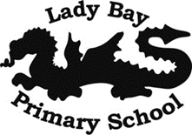
Year 5 History: Ancient Greece
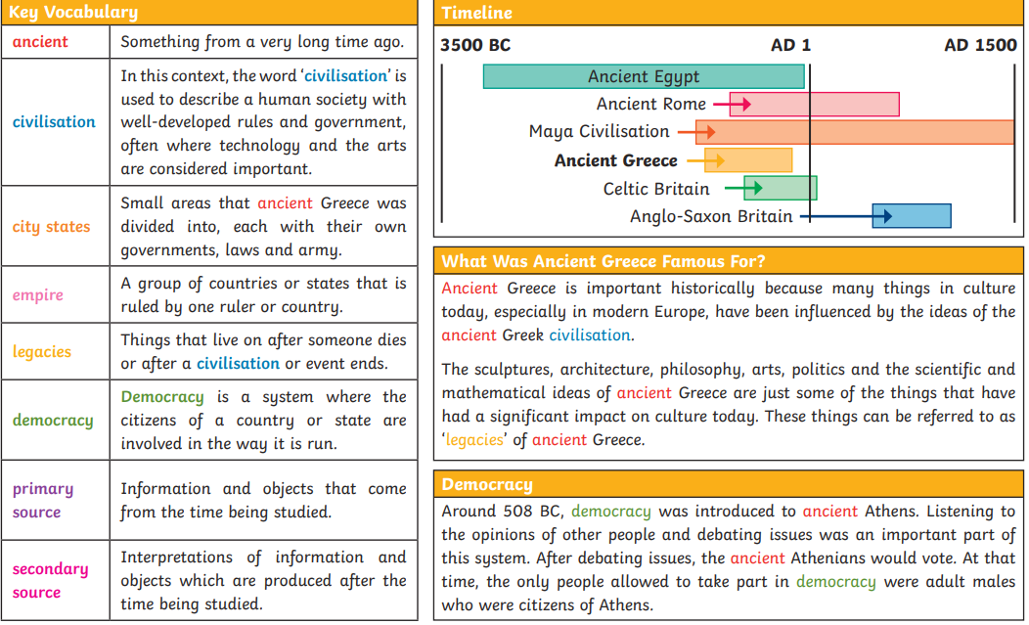
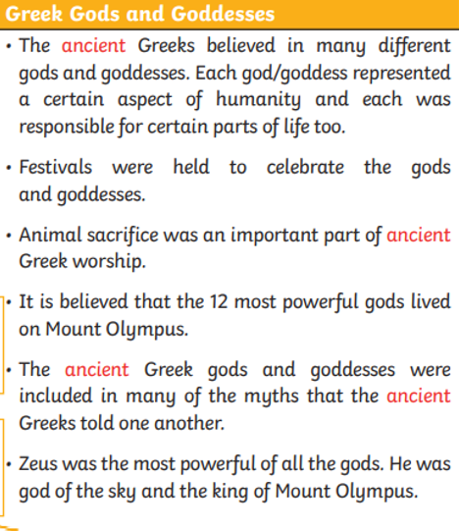
Sticky Knowledge
• To know what an empire is.
• To know what democracy is.
• To understand the importance of Greek vase decoration as a primary historical source.
• To know the differences between the Athenian and Spartan city states.
• To name three Ancient Greek Gods/Goddesses.
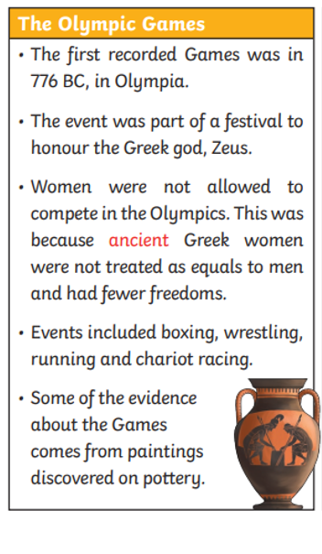
• To know the differences between the ancient and modern Olympic Games.

