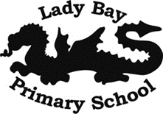
What are some ways Jewish people show their beliefs ?- R.E Term 3
Key Vocabulary
Torah and important scriptures | This is the name of the sacred scroll that some people in the Jewish religion are allowed to handle. All Jewish people follow the words in this sacred book.
Shabbat | This is an important religious festival that Jewish people celebrate weekly with their families. How does this link to the Creation story?
Judaism | This is a religion that many people follow around the world. People in Nottingham also follow this religion.
Synagogue and special place | This is the name of the place where Jewish people worship and pray. We shall be visiting a Synagogue in Nottingham.
Story of Joseph | This is a story that Jewish people read and think about. It considers the treatment he had from his brothers. How does this make you feel?
How and why are some stories important in religion?
Creation Story
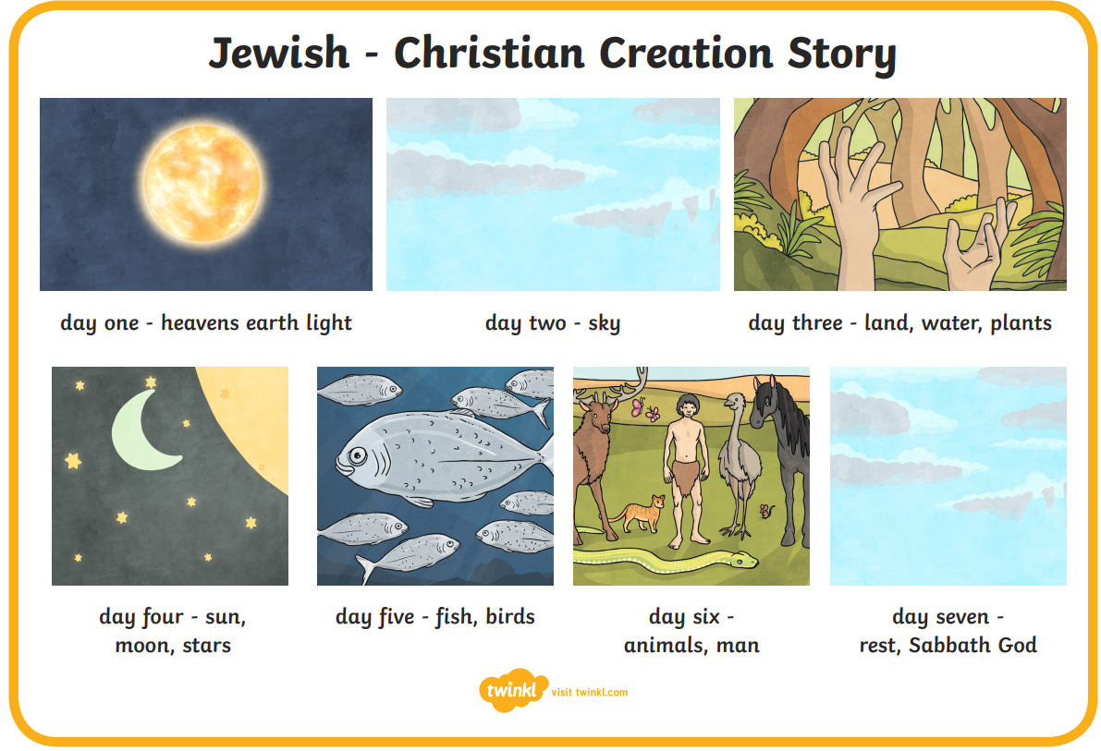

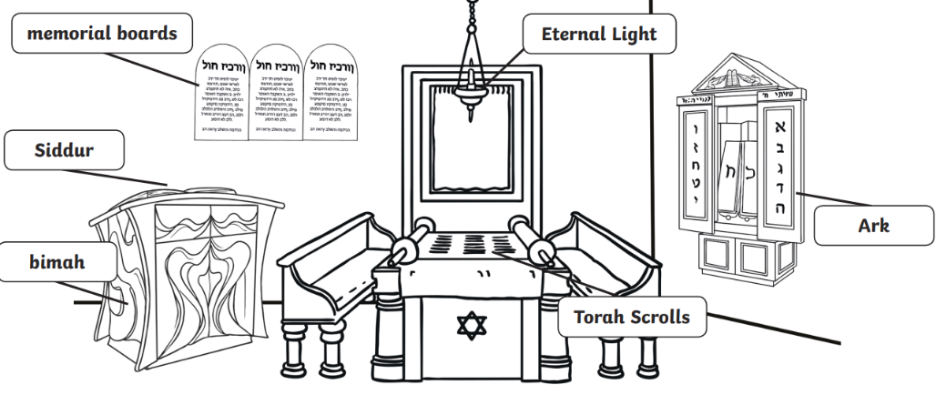
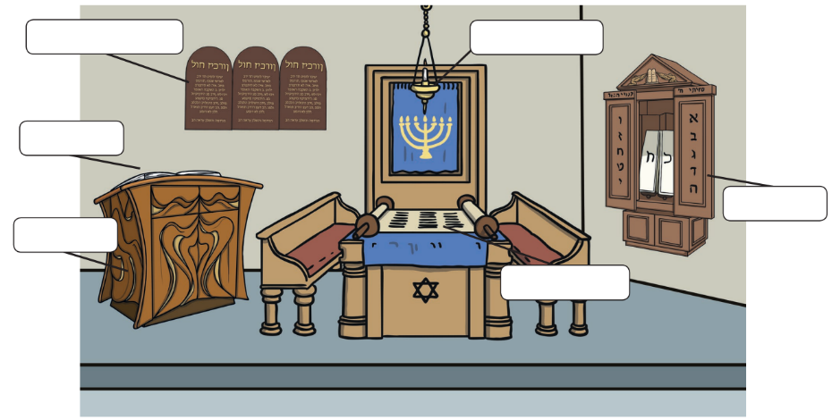
Does it matter what order we retell the creation story in?
God made the world over these days and in this order.

SYNAGOGUE FEATURES AND LABELS TO BE LOOKED AT DURING THE VISIT.

