Key Vocabulary
Moses | Moses was a man who promised to save the slaves from Egypt and take them to a better place. He heard the voice of God and shred the message he had been given.
St Peter | Saint Peter was one of Jesus’ disciples. Jesus described him as ‘a rock’ because he could be depended on.
Good leader qualities | To be a good leader, like Moses and St Peter, you have to have certain qualities. These qualities are: inspiring, encouraging, lead positively and listen to others.
Good news of Christmas | Consider how Angel Gabriel delivered news about a baby being born. Who was excited about it and how did they feel?

What makes some people inspiring to others ?- R.E term 1.2
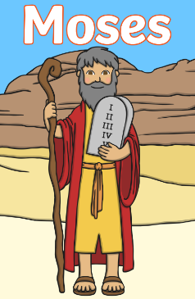
Christmas story
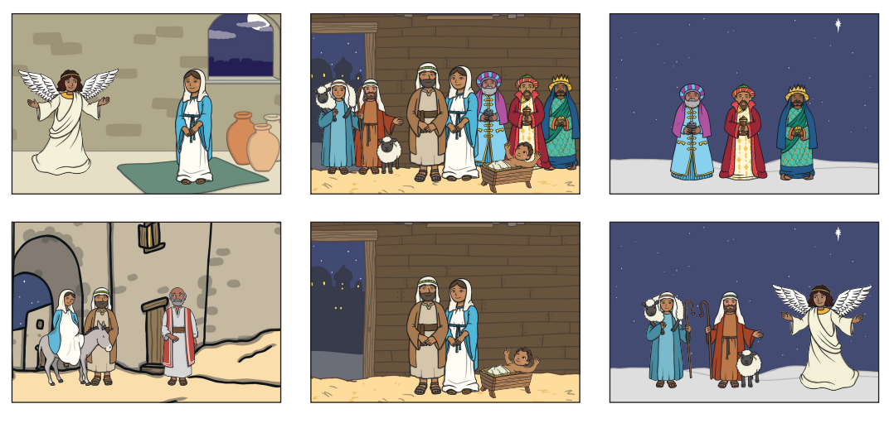

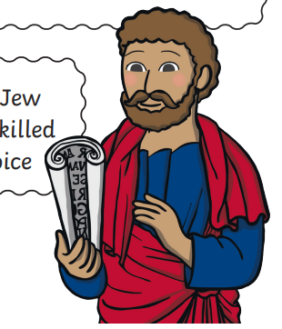
St
Peter

Angel Gabriel
Good news
Shepherds and Kings
Follow the star
Mary and Joseph and their journey.

