Key Vocabulary
Celebration | A special enjoyable event that people organise because it is an annual event like a birthday or something good has happened.
Festival | A special religious celebration that is like a party which can last for hours or days.
Dwali | Diwali is the Hindu Festival of Lights, which takes place between October and November. It is a time for families to get together, give presents and decorate their houses with bright lights.
Hanukkah | Hanukkah is the Jewish Festival of Lights. The word 'Hanukkah' means 'Dedication' in Hebrew. It celebrates a miracle that happened in Jerusalem over 2,000 years ago
Christmas | When Christians remember and celebrate the birth of baby Jesus.
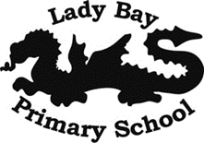
Who celebrates what and why ?- R.E term 1
