Information about classroom routines and activities in Year 5

Introduction
Welcome back after the summer break! We are very much looking forward to meeting the children again and getting back to school life.
Year 5 will be taught by Jenna Beckett, Frank Warren-Oliver and Celia Wilkie – we thought we should introduce ourselves to you individually.
5B
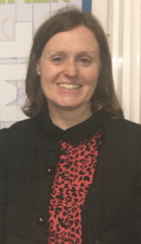
Miss Jenna Beckett
Hello, I am Jenna Beckett. I am keen to get started on a new year and am looking forward to getting to know you all. I have worked at Lady Bay since 2006 and I have taught in Years 3, 4, 5 and 6 here. I have two children and am the coordinator for RHE (Relationship and Health Education). I love reading and live music. Let’s go for it!!

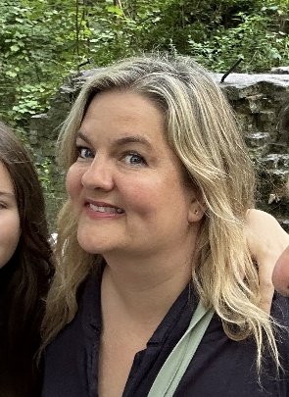
5W
Mrs Celia Wilkie
Hello, my name is Celia Wilkie and I am excited to be working with the fantastic children in Year 5 this year. This is my eighth year at Lady Bay Primary School, where I’ve enjoyed a variety of roles across both Key Stage 1 and Key Stage 2. As a result, I’m a familiar face to many of the pupils we will be teaching this year.
Before joining Lady Bay, I taught in a range of schools across Nottinghamshire, Manchester, East London, and even in France. I have a passion for travel and learning about language, culture, and history—so I’m especially looking forward to exploring the rich and varied topics within the Year 5 curriculum. In my spare time, I love walking in the countryside with my family, going to the theatre, and singing in a community choir.

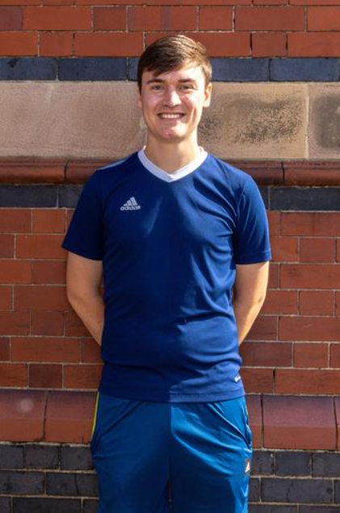
Mr Frank Warren-Oliver
Hello! I’m excited to be back in Year 5 with the awesome Jenna and can’t wait to share a class with the fabulous Celia! I was mainly in Year 6 last year, but hopefully many of the fantastic kids know me somewhat already from covering around school. I’m also taking over from Mrs Wilson as the Science coordinator, so I’m looking forward to some great topics this year like Space. I also love History, Geography and PE; international travel and being active are passions of mine and I typically walk to school from Edwalton! In my spare time, I can usually be found at the football or on a plane.
This year, the children (and teachers!) will be supported by highly qualified and experienced Teaching Assistants: Rachel Latham, Lorna Davies and Di Daglish. They will help the children access the curriculum or support their individual needs.
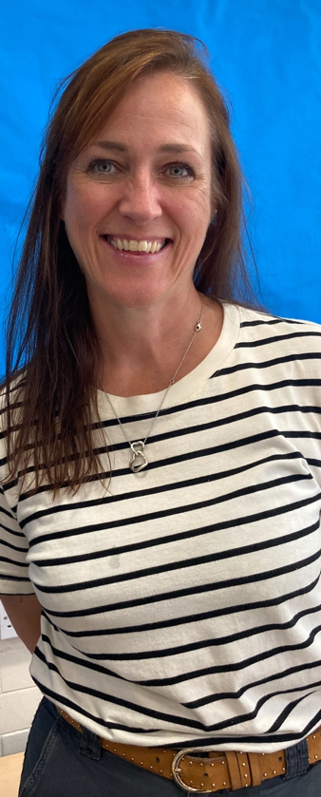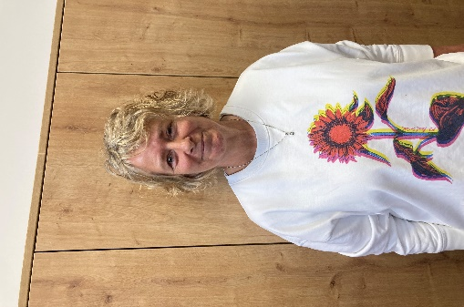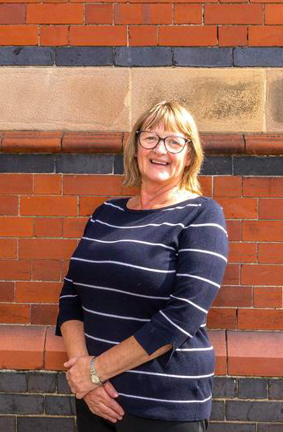

Here is some more information that you might find useful……

Homework
In both classes, homework will be given out on Friday and collected in on the following Friday, or on the date shown on the task sheet. We will be having homework books for children to either record directly or to stick in any sheets.
Alongside the set homework, children should spend some time at home reading, practising times tables and having some spelling practise if necessary. We will usually alternate between English and Maths to support work done in class, but there will also be topic-based homework, usually involving research. Some homework will be differentiated, some will be differentiated by outcome. If your child finds the homework difficult, please let us know before the hand in day.
Homework can be hand-written or word-processed and please ensure any work handed in is clearly named.
Spellings
Spellings are given out on Friday and will be stuck in the Reading Diary and onto a Look, Say, Cover, Spell, Check (LSCSC) sheet which will stay in school for daily practise.
The children will be tested on these spellings on the following Friday and the test will be done in the child’s class jotter. Spellings will be practised in school. We encourage the children to use a dictionary – or parents – to find the definition of any word they do not know the meaning of.
Children will also do spelling investigations, looking at how words with specific letter sequences are formed. Some children will be given spellings specific to their individual needs or fewer spellings per week.

PE
Our PE timetable will be changing on a half-termly basis, but for the first half term PE will be on Monday and Wednesday for 5W and on Monday and Thursday for 5B.
Children should have the school recommended PE kit and please provide clothing suitable for outside PE in cold and/or wet weather. Monday will be our outdoor PE lesson this half term.

Reading Diary
As mentioned previously, each child has a Reading Diary which will be used to record their reading, their spellings and can also be used to record homework and to send messages. If you write a message in the diary, please remind your child to show it to us. Diaries can go back and forth between home and school, but please send them in to school each day as they are an important resource. Children are expected to record what they read/any comments about their book at least four times a week. As part of the reading reward system, parents are requested to sign the diary each week to confirm that children are reading at home.

Rewards Systems
This year, we will be handing out Dragon’s Gold tokens, children can earn points towards a half-termly reward. A Dragon Certificate will be given out during weekly Dragon Assemblies on Fridays.

Multiplication Tables
It is really important that children know by heart their times tables and we will be practising and testing their knowledge every day.
It would be fantastic if you could practise with your child if they are having difficulties, or just to help them increase speed of recall.
Children should know the multiplication sentences and aim to know their inverse operations. For example,
6 x 5 = 30 and from this know that 5 x 6 = 30
They should also know that 30 ÷ 6 = 5 and that 30 ÷ 5 = 6
Any practise is good – chanting tables, random questions, interactive computer games and of course, TT Rock Stars.
If there is a problem
If at any time you have any concerns about your child or anything that you would like to clarify or discuss, please let us know, either by contacting the school office or by leaving a written message in the Reading Diary. We would rather hear of any concerns sooner rather than later.
Curriculum information – the Year Five long-term plan will be available on the curriculum section of the website if you would like to see the subject coverage over the year.
School Website – Please refer to the school website, particularly our class pages, as they will soon be full of class activities and information.
Best wishes for a happy and successful school year,
The Year 5 team

