Lady Bay Primary School
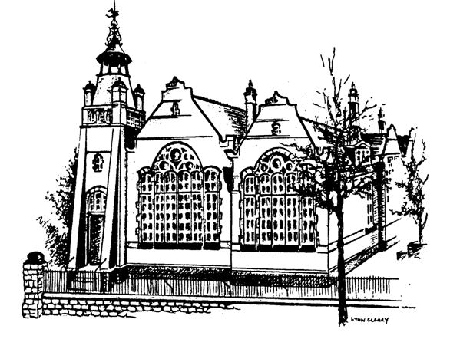

Timestables
Policy

Reviewed By: Gill Willson

Date Reviewed: January 2025

Approved By:

Date Approved:

Next Review Date July 2025

The National Curriculum 2014 states that: “By the end of year 4, pupils should have memorised their multiplication tables, up to and including the 12 x table, and show precision and fluency in their work.”
Introduction
Times Tables are at the heart of mental arithmetic, which in itself helps form the basis of a child’s understanding and ability when working with number. Once the children have learnt the times tables and related divisions by heart, they are able to work far more confidently and efficiently through a wide range of more advanced calculations. Research suggests that if times tables are embedded in long term memory, the cognitive load of mathematical questions is reduced and therefore it is important that children develop their recall of times tables facts. At Lady Bay Primary School, we believe that through a variety of interactive, visual, engaging and rote learning techniques, most children can achieve the full times tables knowledge required by the end of Year 4.
When teaching times tables, the understanding of commutative law is vital (when two numbers can be multiplied in either order and the same answer will be reached). This understanding reduces the number of times table facts to learn and reduces cognitive load as it allows the children to change the operation order to suit their preference and aid their times tables recall.

Aims
1. To improve teaching of times tables and to raise overall knowledge of the times tables and related division facts across the school.
2. To ensure children learn their times tables to ensure good outcomes in end of Year 4 assessments.
3. To ensure progression in times tables through the year groups, following the National Curriculum recommendations. In keeping with this aim, a Times Table Progression Map has been created, identifying expectations and methods used for each year group.
4. To monitor teaching and learning of times tables and related divisions, within our school, to ensure successful learning outcomes in all year groups.
5. To develop our knowledge of language associated with times tables: ‘times’, ‘lots of’, ‘product’, ‘multiplied by’.

National Curriculum Expectations
Year Group | NC Expectations | Specific Tables (new in bold)
Y1 | Count in multiples of 2, 5 and 10. Recall and use all doubles to 10 and corresponding halves.
Y2 | Recall and use multiplication and division facts for the 2, 5 and 10 multiplication tables, including recognising odd and even numbers. | 2, 5, 10
Y3 | Recall and use multiplication and division facts for the 3, 4 and 8 multiplication tables. | 2, 3, 4, 5, 8, 10
Y4 | Recall and use multiplication and division facts for multiplication tables up to 12x12 | 2, 3, 4, 5, 6, 7, 8, 9, 10, 11, 12
Y5 | Revision of all times table and division facts up to 12x12 | All
Y6 | Revision of all times table and division facts up to 12x12 | All

Teaching Approaches to Times Tables
Times table facts should be taught explicitly through a variety of methods to support all children’s ability to recall and apply this knowledge. At Lady Bay School, we will use the following teaching approaches:
• Games
• Songs
• Abstract, Concrete and Pictorial Resources
• Online Platforms e g TT RockStars , Hit the Button, Daily 10
• Encouraging and making conceptual links to the real world
• Building on known number facts (commutativity)
• Stories
• Reasoning and Problem Solving
• Rote Learning
• Chanting
• Mastery Approach (White Rose maths lessons)
• Speed tables grids
• Encouragement of home learning

These methods will be applied in maths lessons, but also in specific 15minute targeted sessions, every day. In Year 4, practise multiplication times table checks will be carried out in order to prepare children for the official multiplication test in June.

Assessment
Children in years 2-6 will be assessed on their times table knowledge at regular intervals to ensure that they are secure in the recall of the facts required of them by the end of their current year group.
In line with our mastery approach to mathematics, in order to embed learning and understanding securely, whilst reducing cognitive load, years 2, 3 and 4 follow a programme that allows time to fully learn and practise each new times table over a half term in school before advancing to another times table for their year group in the next half term.

Children will have the opportunity to advance to higher levels of challenge within the same times table, assessing their ability to remember the times table out of sequence as well as be secure in related division facts.

Home Learning
In addition to their work in school, children will be encouraged to continue their multiplication table practise at home as part of school homework. Access to TT RockStars is available at home, using the child’s personal log in. Parents will be informed that this resource is available and will be requested to support their children in practising on line or by using other non-digital methods.

