
Year 5 – RE - What Matters to Christians? What is expected of a person following a religion or belief?
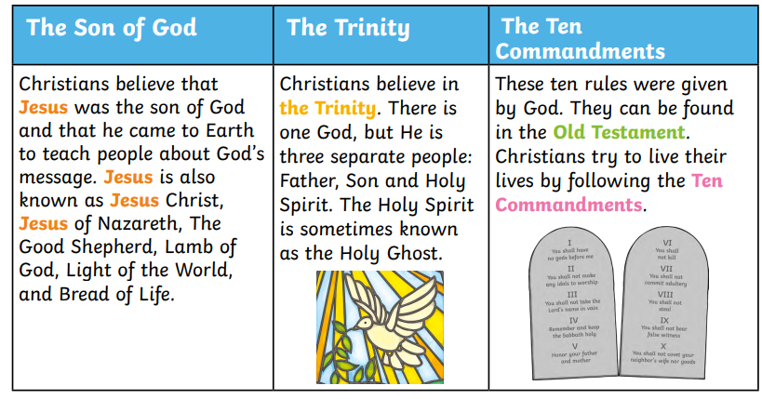
Key Vocabulary
Devotion - If you feel loyal and loving toward someone or something.
Commitment - A committed Christian is a believer who has decided to follow Jesus, and is loyal to God, their church, and the Christian lifestyle.
Salvation - Salvation is the act of saving from sin or evil, or sometimes just from an unpleasant situation.
Forgiveness - letting go of feelings of resentment and vengeance.
Eucharist - The Eucharist is a re-enactment of the Last Supper, the final meal that Jesus Christ shared with his disciples before his arrest, and eventual crucifixion. At the meal Jesus ate bread and wine and instructed his disciples to do the same in memory of him.
Atonement
Parable

