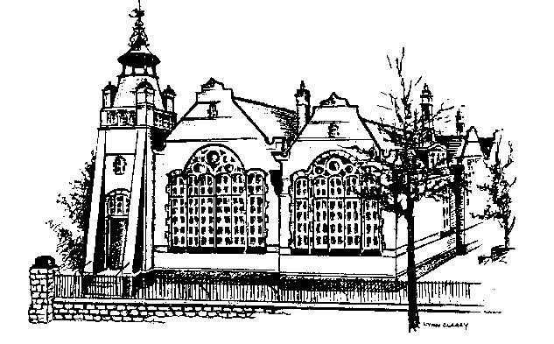

LADY BAY PRIMARY SCHOOL
Trent Boulevard, West Bridgford, NG2 5BD Tel: 0115 9747001 Fax: 0115 9747002 email: office@ladybay.notts.sch.uk website: www.ladybay.notts.sch.uk
Headteacher: Mr Steve Border

Lady Bay School uniform is available from S & A Uniforms http://sauniforms.co.uk/
Tel: 07970 875 671

- Plain navy-blue sweatshirt, jumper or fleece (with or without Lady Bay Dragon Logo but no other logo)
- Plain navy-blue cardigan (with or without Lady Bay Dragon Logo but no other logo)
- Plain white or green polo shirt (with or without Lady Bay Dragon Logo but no other logo)
- Plain black, navy-blue or grey trousers (not jeans)
- Plain black, navy-blue or grey shorts or skirt/pinafore
- Black, navy-blue, white or grey socks or tights (plain)
- Black shoes (no open toed sandals or trainers)
- Summer: blue or green gingham check dress

PE Kit: Children are expected to wear their PE kit on the day they have PE
The kit includes the following -
- Plain white or navy-blue T-Shirt
- Plain black or navy-blue shorts
- Plain black or navy-blue jogging bottoms
- Plain black or navy-blue zipped hooded top
- Trainers
Accessories
- Plain headband or bobble
- 1 pair of small studded earrings (however, these must be removed for PE)
- With discussion with the Headteacher, children can wear religious bands

Children are not permitted to wear any other jewellery, makeup, temporary tattoos or nail polish.

