
Year 5 – RE - How do people’s beliefs about God, the world and others have impact on their lives?
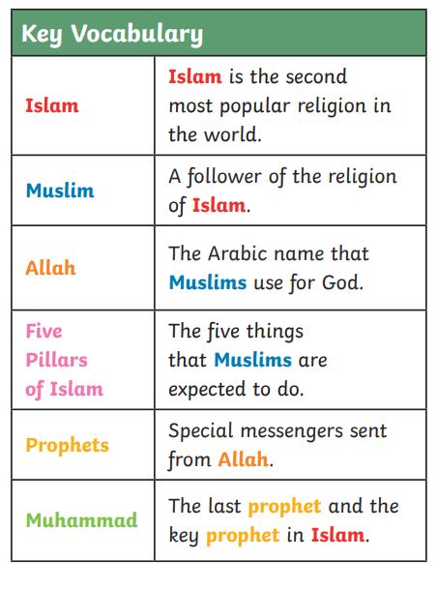
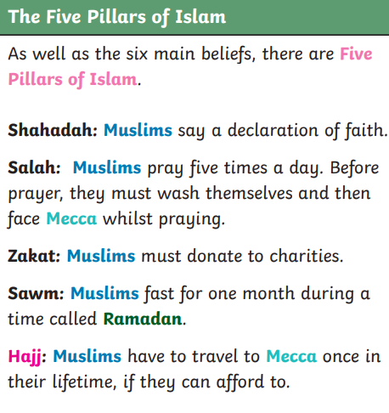

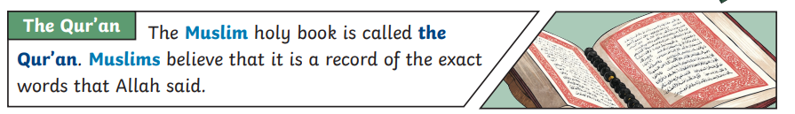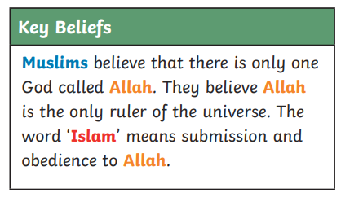

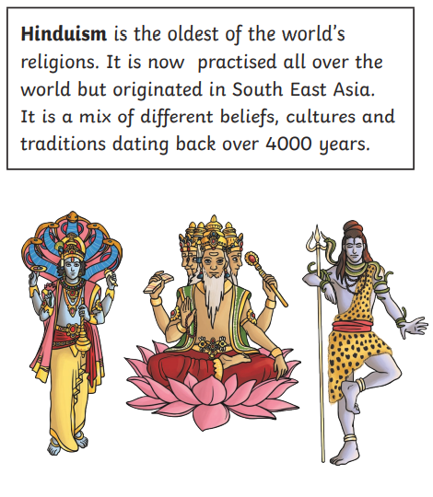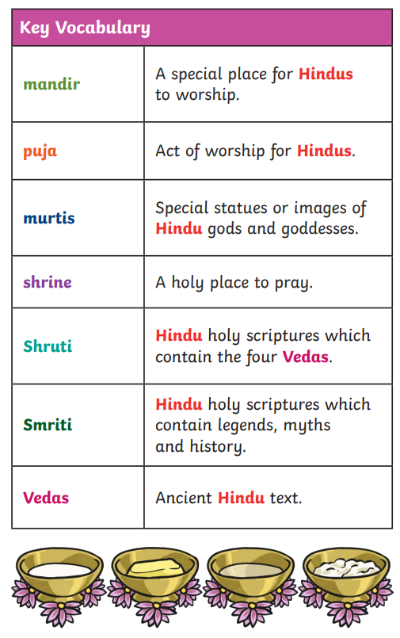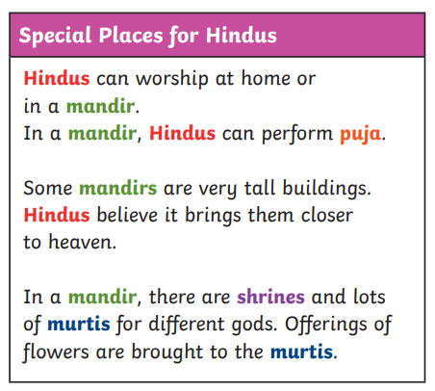
Ahimsa – the principle of non-violence.
Karma – the belief that all actions bring consequences. The Hindu belief in reincarnation draws on the idea of karma. The law of karma is not limited to one lifetime but many lifetimes. If people do negative things in this life, they may pay for these in their next reincarnation.

Some people either have no religion or belief in god (atheists) or do not ally to any religion but believe in a spiritual being (agnostic).

