Key Vocabulary | Definition
Inspirational | To fill others with ideas or enthusiasm
Religion | A system of beliefs and worship; beliefin and worship of a God or gods
Islam / Muslim/ Qur’an | Islam is the religion followed by Muslims. The Qur’an is the holy text of the religion. Muslims believe in one God, Allah, and Muhamad is his prophet.
Hinduism/Hindu | Hinduism is the religion of Hindus. It is a pantheistic religion with many gods and goddesses. It is one of the religions of India.
Christianity/Christian/ Catholic/Protestant/Methodist/Quaker | Christianity is the religion followed by Christians. Catholicism, Protestantism, Methodism etc are different forms of Christianity. Christians commonly believe that Jesus is the son of God.
Prophet | A religious teacher believed to be inspired by God.
Spiritual | To do with the human soul in a religious context.
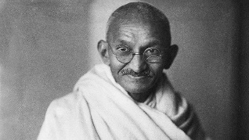


Session 1: Look at the lives of a range of inspirational leaders who have been influenced by their religious beliefs eg: Mahatma Ghandi, William Booth, Mother Theresa of Kalkata, Desmond Tutu, Hany El-Banna. Children select an inspirational figure and will research their early life and the factors that influenced them.

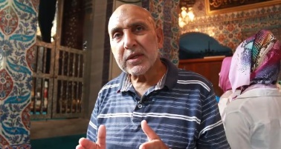
Session 2: Consider the information gathered from the previous week about the life of an inspirational person and use this to assess thoughtfully what makes this individual inspirational to others. This requires the children to have a thorough knowledge of points in the individuals life where their actions or words have caused others to act.
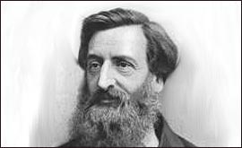

Session 3 and 4: Analyse all the information and thoughts to put together a set of questions for the inspirational figure to answer in an interview. When the important questions have been decided on, the answers to the questions are put together with reference to the religious background of the person, using quotations and references to religious texts that have inspired them in their lives and in the actions they have taken.
Session 5: After final adjustments, pairs of children will present their interview with one child as the inspirational figure, answering the prepared questions for the audience. In this way, children in the class will gather information about a range of inspirational figures of different religious beliefs/different sexes/different upbringing/different time periods and can consider if there are similarities that contribute to their ability to inspire others.
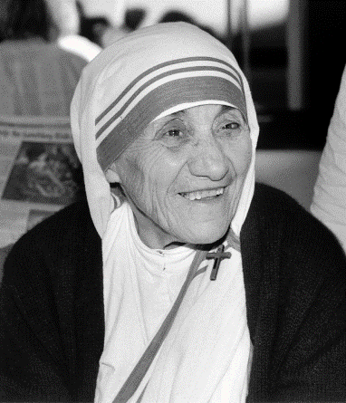

Sticky Knowledge for children at the end of this RE topic:
- To name four inspirational people and their religions.
- To know basic biographical facts about one inspirational person.
- To explain how their religion influenced them in their lives and actions.

Additional Easter Session in Spring 2: What matters at Easter today?

Vocabulary: Palm Sunday, Passover, communion, disciples, Sabbath, crucifixion, resurrection, Easter.
Investigating the events during Holy week in a local Christian community, then deciding on the 10 most important features, ranking them in perceived order of importance. Compare these with 10 things that happen in their own families, at this time. What is the same? What is different?

