Key Vocabulary | Definition
Judaism/Jew/Jewish | Judaism is the religion of the Jews, based on the Old Testament of the Bible and the Talmud. Jews believe in one God as the creator of all things.
Rabbi | A rabbi is the religious leader of a congregation and the minister of a synagogue.
Torah | The Torah is the sacred script of Judaism, usually in the form of a scroll.
Synagogue, Shabbat | The Synagogue is the Jewish place of worship. Shabbat (which is on a Saturday) is the Jewish Sabbath when Jews attend Synagogue.
Hebrew | The ancient language of the Hebrews (Jewish people).
Menorah | A seven-branched candelabrum (candlestick); an emblem of Judaism and the badge of the State of Israel.
Bar mitzvah/ Bat Mitzvah | Bar Mitzvah is the celebration of a boy assuming full religious obligations, usually at the age of 13 years. The Bat Mitzvah is the female equivalent.
Kippah/tallit | Tallit – a white fringed shawl worn over the head of Jewish men in religious ceremonies. Kippah – a skull-cap worn during prayer (or always for Orthodox Jews).
Passover | Also called Pesach, a festival to celebrate the sparing of the Israelites in Egypt when God caused the Egyptian first- born males to die.
Persecution/discrimination | Persecution – to harass or mistreat because of race/religion. Discrimination – unfair treatment of a person because of their race/religion etc.
Upstander/bystander | Upstander – a person who speaks out or helps someone who is discriminated or persecuted. Bystander – a person who sees discrimination and persecution but does nothing.
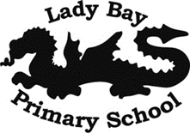

Religious persecution is the systematic mistreatment of an individual or a group of individuals as a response to their religious beliefs. Persecution is to treat someone cruelly or unfairly because they are Jewish.
Religious discrimination is treating a person or group differently because of the particular beliefs which they hold, about a religion. Discrimination is when a person is treated differently (not in a good way) because they are Jewish.

What was the Kindertransport?
In Germany during the 1930s, there was a steady increase in discrimination against the Jewish minority. Many new laws were passed, restricting what Jews could do, where they could work, their freedom to communicate and to travel. Many Families were worried about the escalation of anti-Jewish feelings, stirred up by Adolf Hitler and the Nazi Party. Appealing for help from other countries, the UK agreed to accept Jewish children as refugees, but did not allow their parents to come with them. This movement out of Germany, usually by train and then by boat, was know as the Kindertransport (literally ‘Children Moving’).

Who were the Upstanders?
Sir Nicholas Winton, Sophie Scholl and Pastor Martin Niemoller all risked their lives to help or support those who were persecuted by the Nazis. Sir Nicholas Winton helped many Jewish children escape from what was then Chekoslovakia. His part in saving all these lives remained hidden for decades until, famously, he appeared on a show hosted by Esther Rantzen, where he was a member of an audience which was made up of adults who were alive because of his actions.
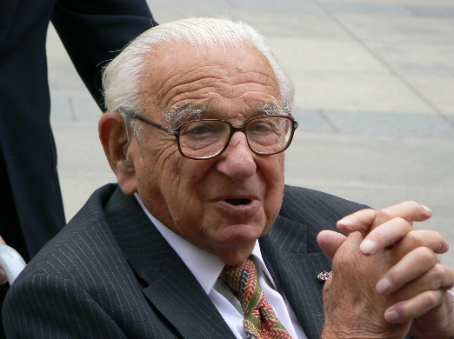
Sophie Scholl was a student and a political opponent of the Nazi party who, together with her brother, spoke out against their treatment of minority groups. They formed the ‘White Rose’ resistance group and eventually paid for their brave stand with their lives. Pastor Niemuller also spoke out against the actions and behaviours of the Nazi Party, famously writing a poem about being a bystander while others were persecuted – until the bystander themselves became the target.

Sticky Knowledge
- To know five pieces of key vocabulary related the Judaism.
- To understand the difference between discrimination and religious persecution.
- To know what the Kindertransport was.
- To know what an upstander is (and name one).

