Key Vocabulary
Charity | An organisation that provides help and raises money for those in need.
Freedom | The right to think and speak as one wants.
Justice | The act of being fair and responsible.
Agape | The highest form of love (unconditional) for Christians and Jesus had this love for humans.
Ummah | An Islamic idea meaning ‘community’ and living as one regardless of background.
Ahimsa | The Hindu principle of not causing harm to other living things.

Year 6 – How do religions respond to global issues of human rights,
fairness, social justice and the importance of the environment?



CAFOD (Catholic Fund For Overseas Development) is a Catholic charity that supports people in far to reach places and war zones.

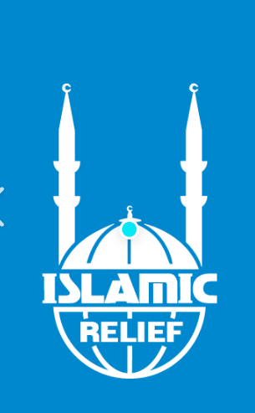

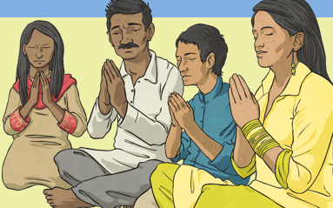
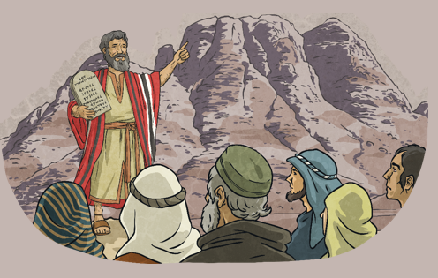
For Muslims, freedom and justice means that god has given them the ability to make good choices and no one’s freedom should get in the way of another’s.
s.
For Hindu’s freedom and justice means freedom of reason, thought, feeling and will.
The story of Moses and the 10 commandments shows how the Jews were given freedom to practise their religion freely without imprisonment and slavery.
Islamic Relief is a Muslim charity that provides long term and emergency aid across the world.

