
Year 6 – How are religious and spiritual thoughts and beliefs expressed in arts and architecture and in charity and generosity?

Key Vocabulary
Architecture | The science and art of designing buildings. People who practice architecture are called architects.
Sacred buildings | Special places for those with a faith - a place in which to worship.
Gurdwara | A place of worship in Sikhism.
Langar | The free kitchen in the Gurdwara where everyone is treated equally and offered vegetarian food.
Community | A group of people living in the same place or people who have the same attitudes and interests in common.




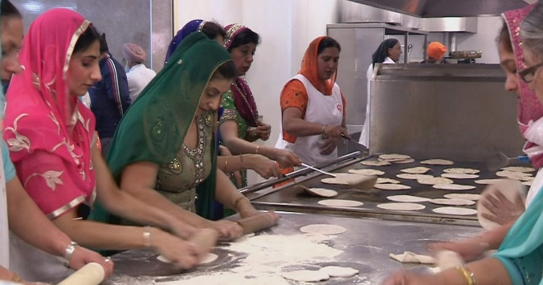
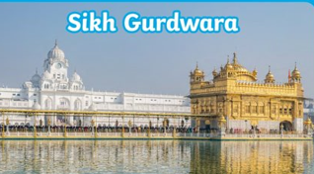
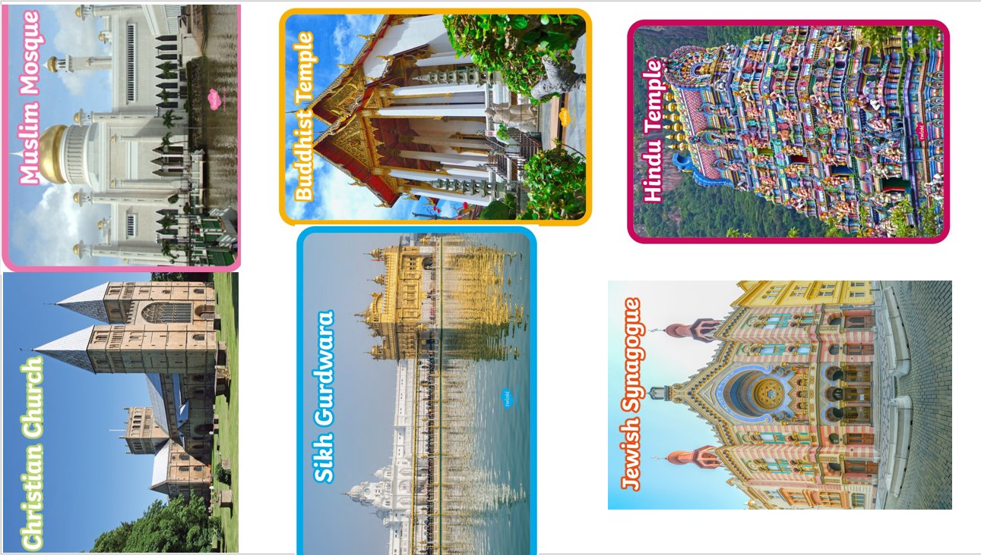
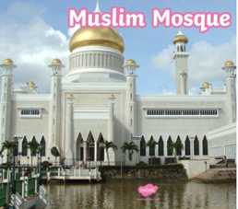
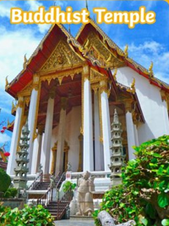
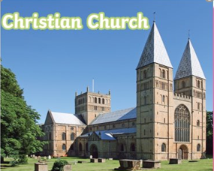
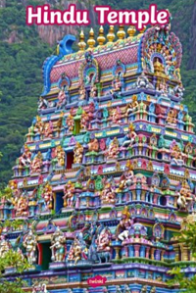
Religious charities
Langar
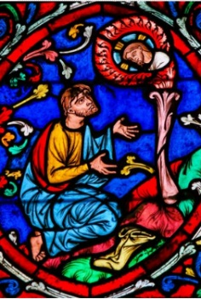
Sacred religious buildings around the world
Stained glass is most commonly seen in Christian architecture. It became popular in church windows during the Gothic period of the Middle Ages. The coloured glass was meant to imitate the appearance of precious stones.

Stained glass windows

