Key Vocabulary
Qur’an | Holy book of Islam. This book is believed to be written directly by God  Through the prohet muhammad and some muslims call it the final  testament
Mosque | Place of prayer for Muslims or followers of the religion of Islam. Many mosques are large buildings with towers or domes and the inside of a mosque always include an open space for worship. The floor will be covered with rugs or mats
Prophet | Someone speaks on behalf of god
Lords prayer | Prayer of Christianity that Jesus taught his followers. It is an example of how to pray and what to believe as Christians
Allah | It is an Arabic term for God. Muslims use many names to describe God but “Allah” means all of the Gods.
Communal | Something that is shared by all members of a community or religion
Atheist | Someone who does not believe in God.
Humanist | They do not believe in god. They do not follow a traditional religion

Year 3 – religion, family, community and prayer - RE

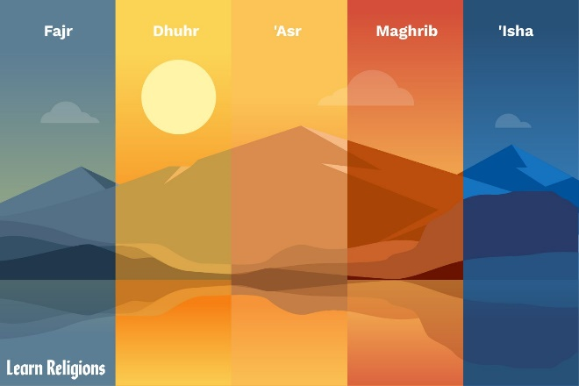
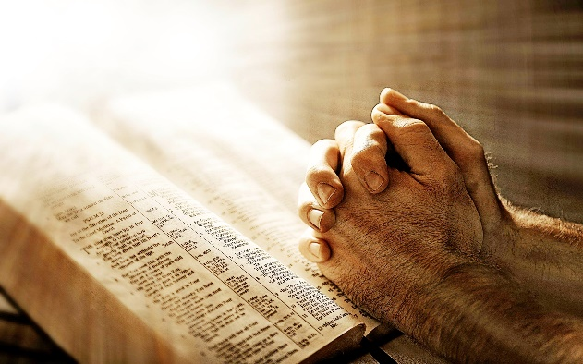
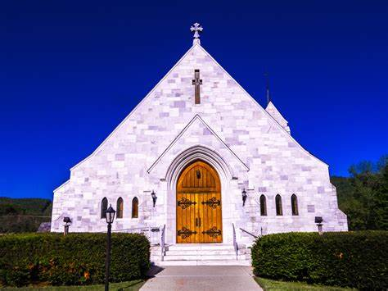
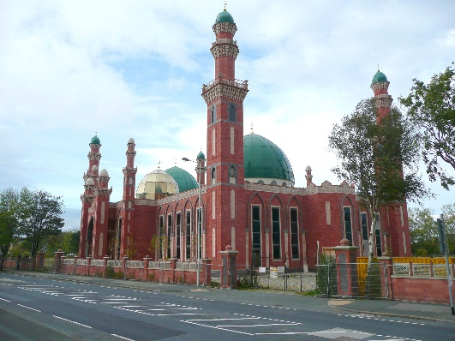
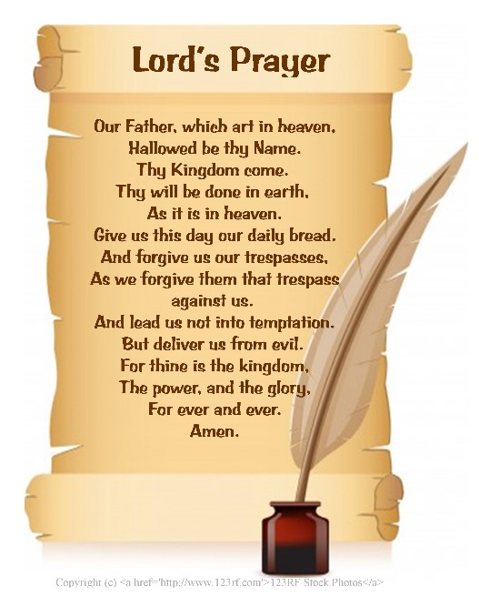
Prayer allows Muslims to communicate with Allah. Christians and Muslims can pray anywhere.
Christians may go to church and pray, Muslims will go to a mosque
The lord’s prayer is a common Christian prayer
These are the 5 daily prayers for every Muslim

