Key Vocabulary
Prayer | The act of talking to God, or a special person/figure special to a religion.
Worship | Religious people worship the God they love and respect through words, thoughts and actions.
Temple | Where Hindu’s go to worship.
Mosque | Where Muslim’s go to worship.
Church | Where Christian’s go to worship.

Year 3 – Where, How and Why do people worship?

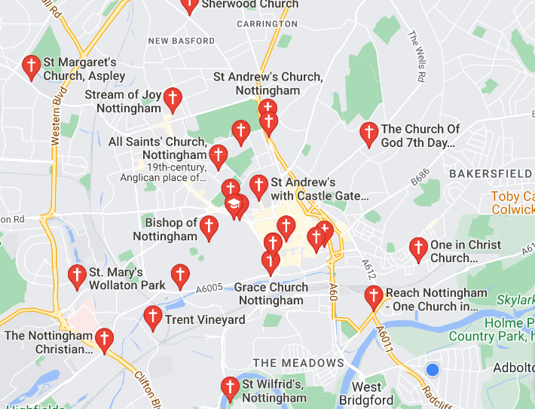

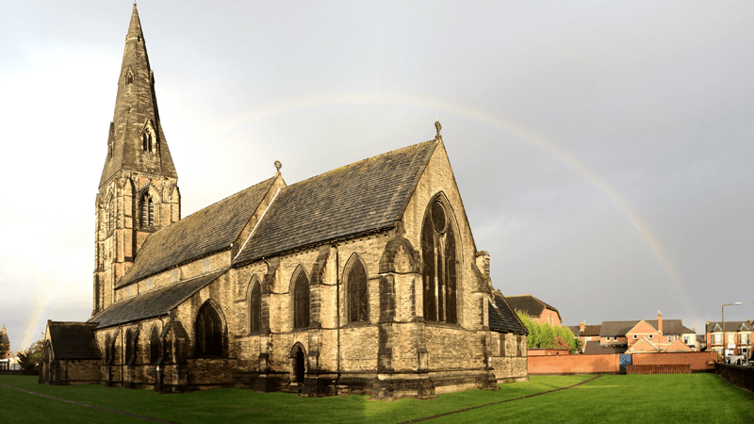
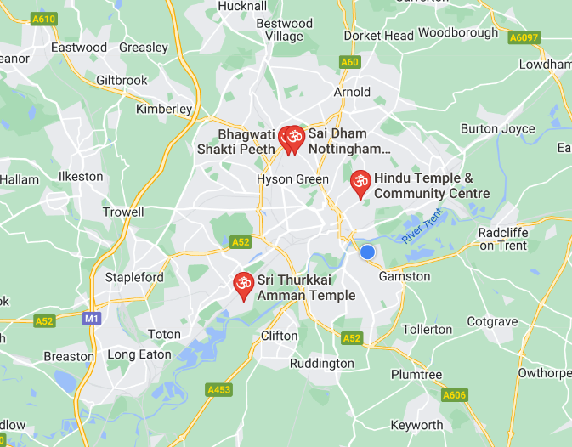
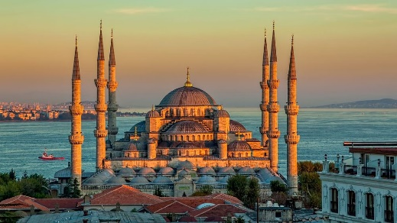
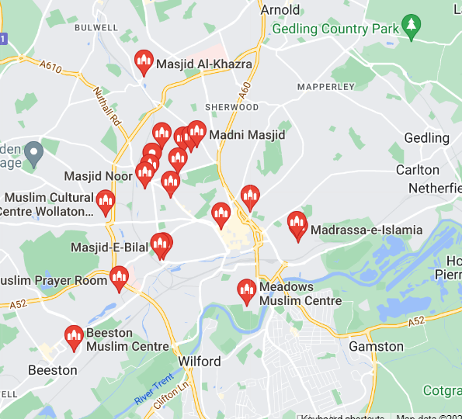
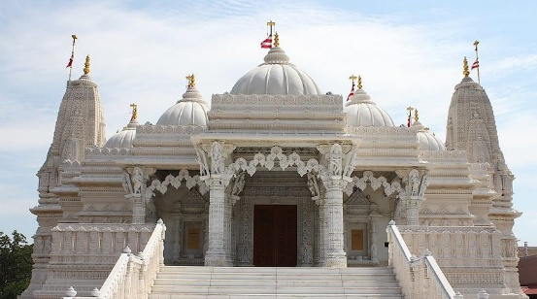
Mosque – A Muslim place of worship
A Temple – a Hindu place of worship.
Church – A Christian place of worship

