Key Vocabulary
Holi | A Hindu festival that celebrates spring, love and new life.
Gods and Goddesses | A deity or supernatural being considered to be sacred or worthy of worship be a religion. It is often seen as having power or authority over the universe, nature or human life.
Festivals | A day or period of celebration, often for religious reasons.
Aum or OM | A symbol that shows the dawn of creation. It symbolises the universe.
Temple | A building for religious worship.
Mandir | A Hindu temple.
Diwali | The Hindu festival of light.

Year 3 – Hinduism

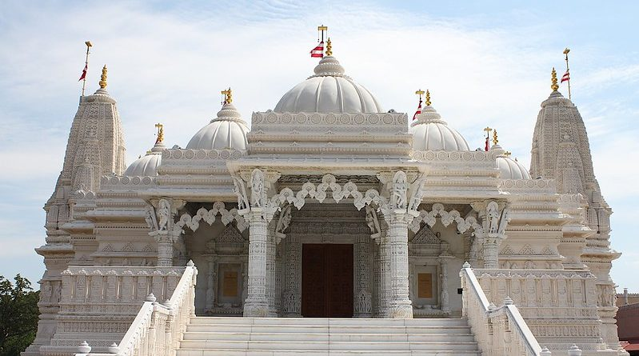
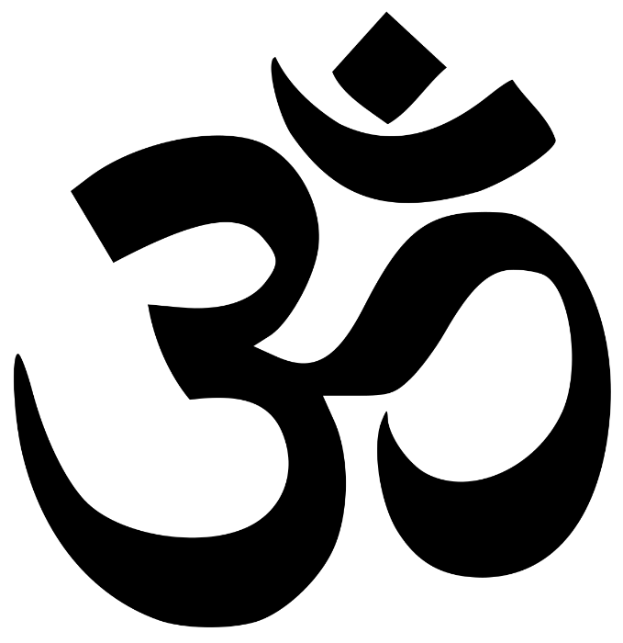

Mandir – Hindu Temple
Aum Symbol

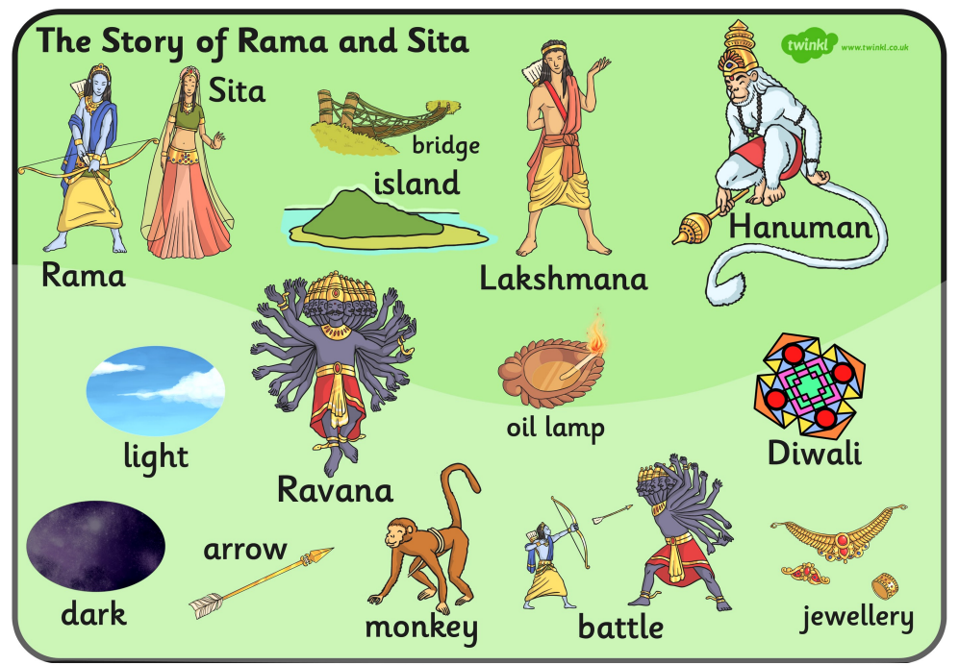
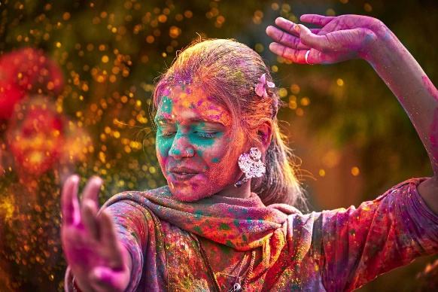
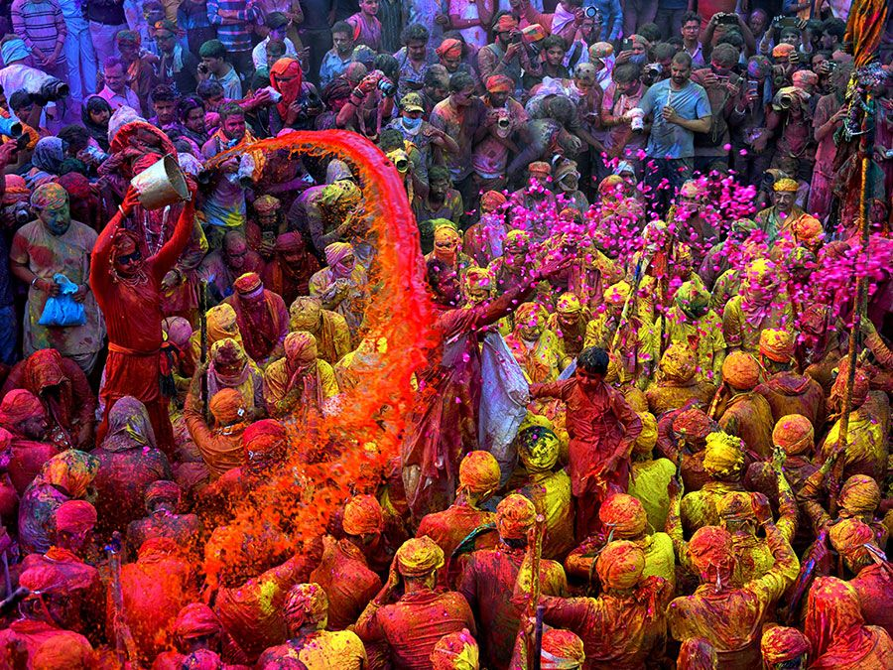
Hindus celebrating Holi with power paints.

