Key Vocabulary
Christian | A person who follows Christianity.
Spiritual | A sense of greater meaning linked to the human spirit or soul, it can also link to a religious belief.
Christmas | A Christian festival celebrating the birth of Jesus Christ.
Easter | A Christian festival celebrating the resurrection of Jesus Christ.
Pentecost | A Christian festival celebrating the descent of the Holy Spirit on the disciples.
Harvest festival | A celebration of the annual harvest where people donate gifts, typically of food, to the poor.
Commitment | The quality of being dedicated to a cause or belief.

Year 3 – Beliefs and Questions

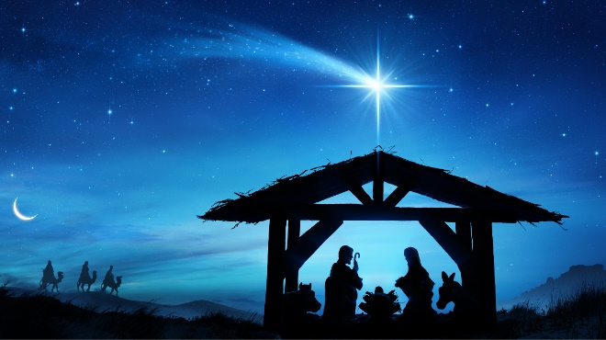
Christmas

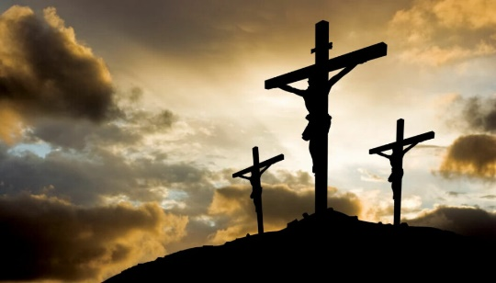
Easter

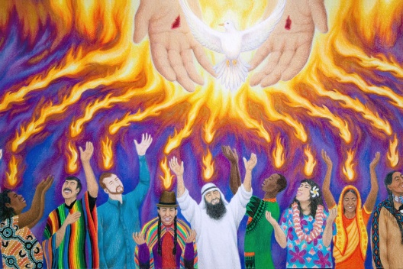
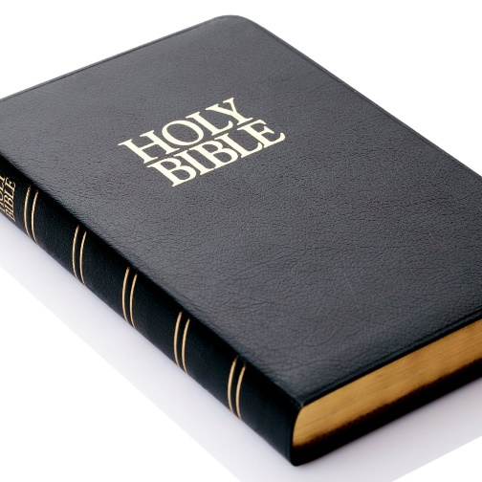
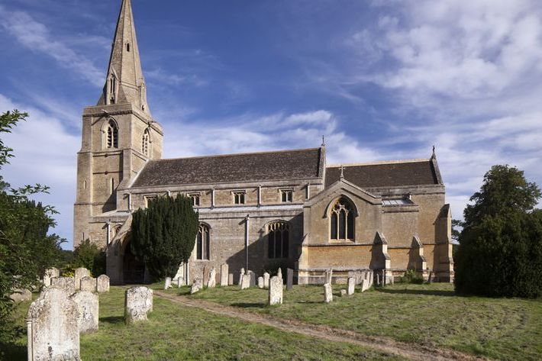
Pentecost
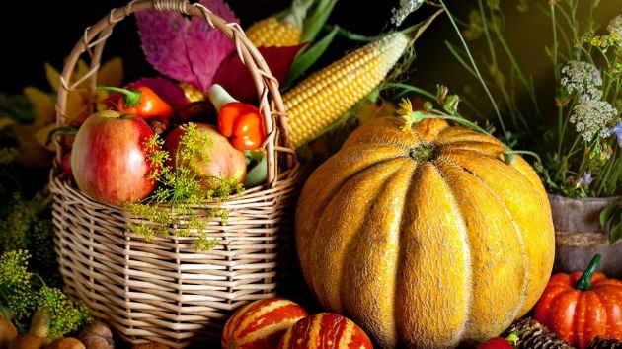
Religious building and book for Christians.
Harvest

