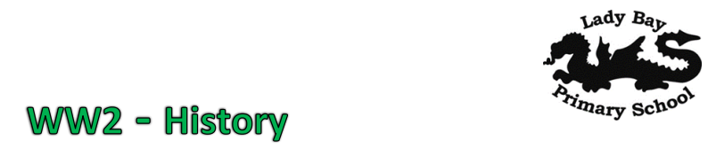
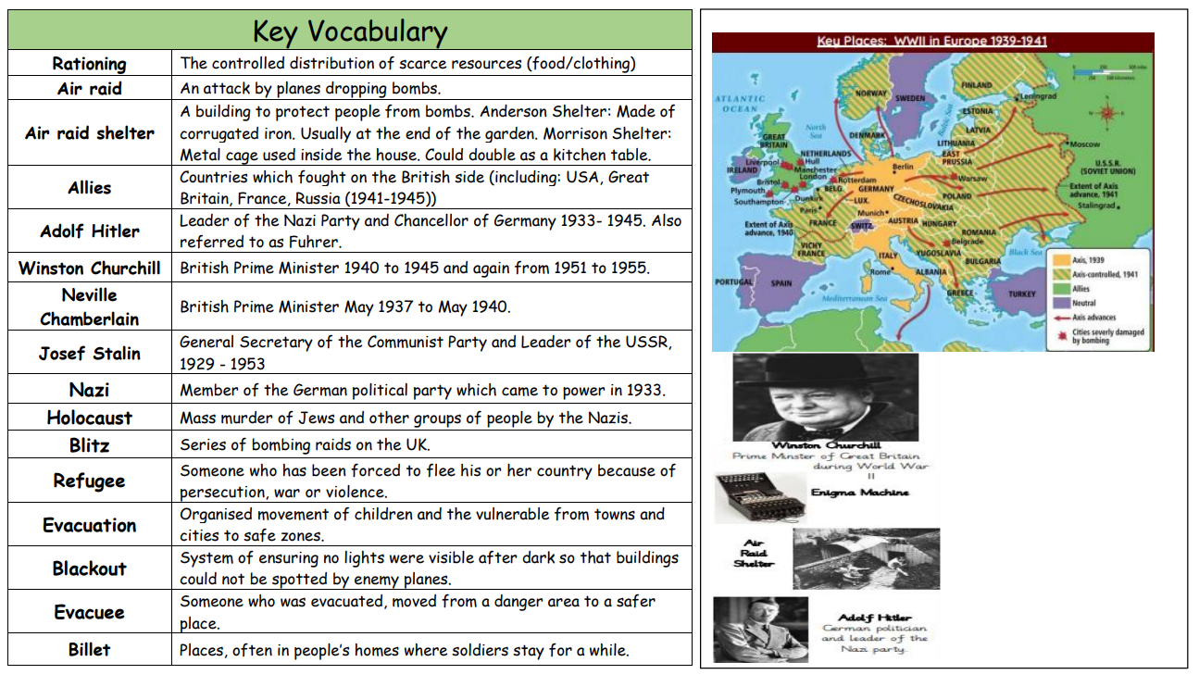

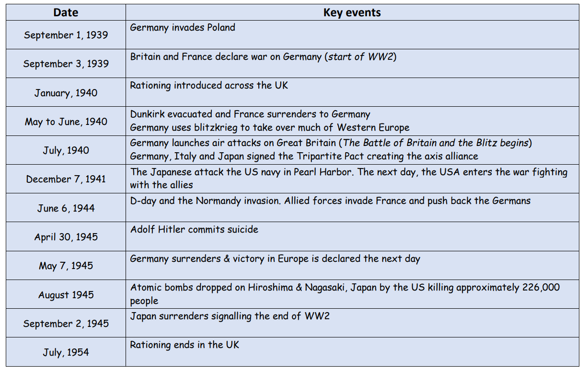 Sticky Knowledge

• Give three pieces of evidence indicating WW2 impact on Lady Bay.
• To know when WW2 started and ended (Jan 1939 to Sept 1945).
• To know what an evacuee is.
• To know how families tried to protect themselves against bombing in WW2.
• To know the difference between an Anderson and a Morrison shelter.
• To know three key figures (people) in World War 2.

