Key Vocabulary
Wisdom | Having experience, knowledge and good judgement.
Sacred | Very holy and special.
Bible | The sacred text of Christianity.
Parable | A story told by Jesus, to teach a particular lesson.
Qur’an | The sacred text of Islam.
Guru Granth Sahib | The sacred text of Sikhism.
Torah | The sacred text of Judaism.
Humanist | People who don’t believe in a religion or a God. Their moral values are based on human nature and life experiences.

Year 6 – What can we learn by reflecting on words of wisdom from religions and world views?

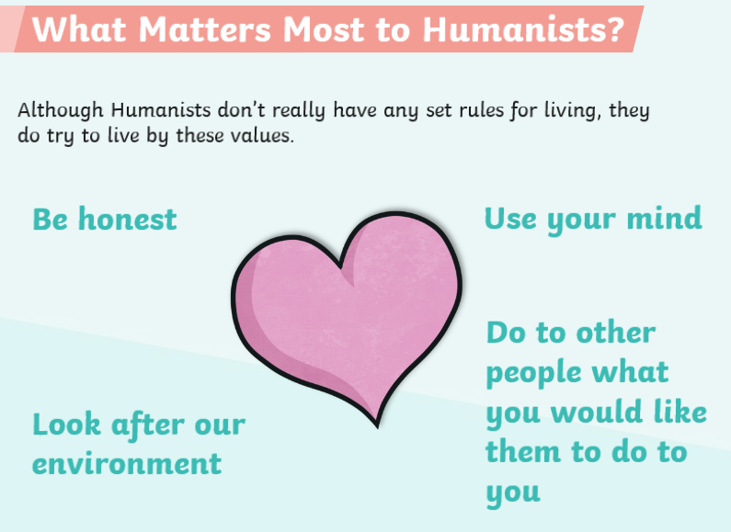

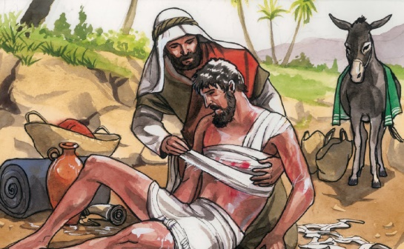
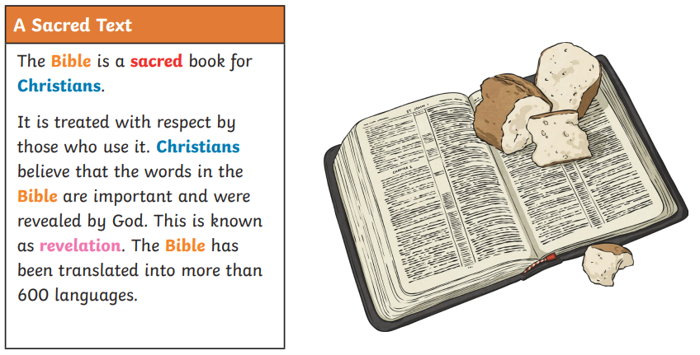
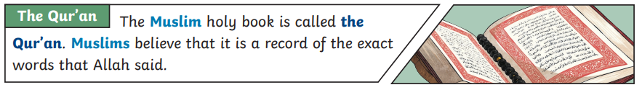
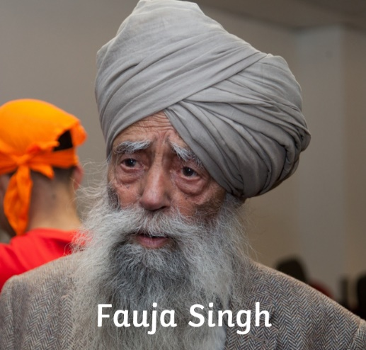
Parable – The Good Samaritan
Fauja Singh is a famous sikh who used his beliefs to overcome challenges in his life.

