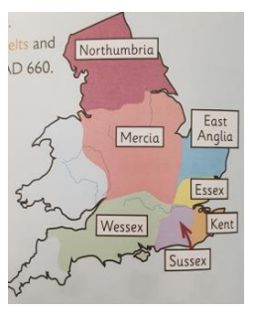
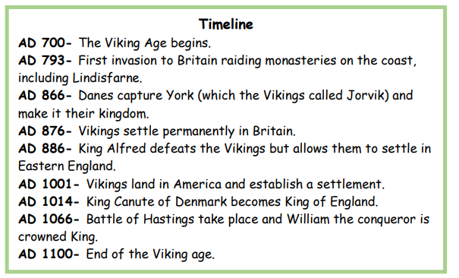
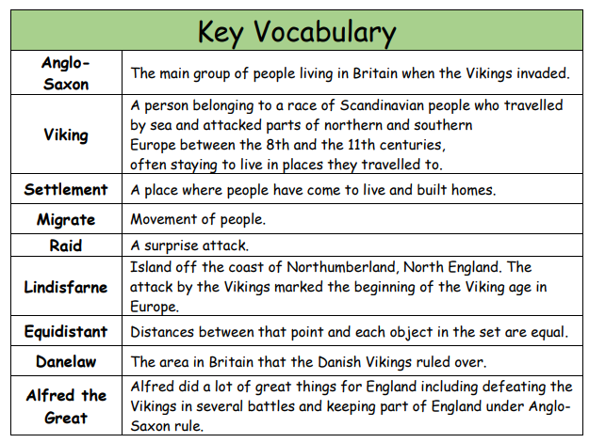
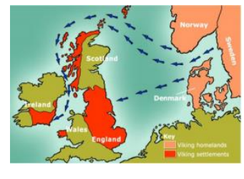
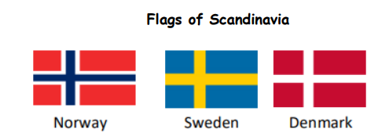

Viking Migration
Anglo Saxon Seven Kingdoms
Sticky Knowledge:
- Anglo Saxon ‘England’ was divided into 7 kingdoms, each ruled by a different king.
- The attack on Lindisfarne marked the beginning of Viking invasion in 793AD.
- The Vikings came from Scandinavia (Norway, Sweden and Denmark). They fought the Anglo Saxons for land.
- In 886 AD the Danelaw was created to encourage peace. North east England was given to the Vikings and the rest of England to the Anglo Saxons.
- Alfred the Great unified the remaining Anglo-Saxon land and is seen as ‘great’ because of all the progress he encouraged.

