Key Vocabulary
Pilgrimage | A visit to a place that is considered special, where you go to show your respect
Pilgrim | Person who goes on a pilgrimage
Ritual | A religious ceremony consisting of a series of actions performed according to a prescribed order
Symbol | A religious symbol is an iconic representation intended to represent a specific religion, or a specific concept within a given religion
Community | The condition of sharing or having certain attitudes and interests in common
Commitment | Commitment is a strong belief in an idea or system
Values | Religious values define what people expect of themselves and of others based on the beliefs common to the religions they practice

Year 4 – Pilgrimages

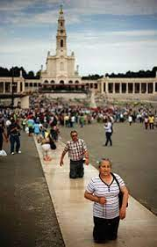
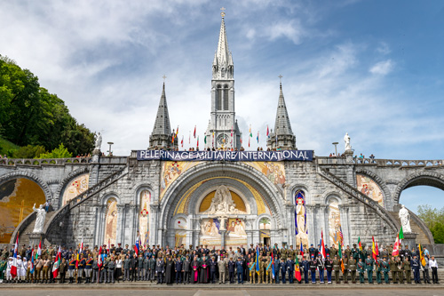
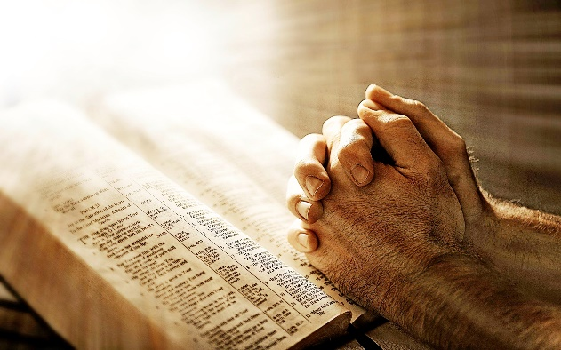
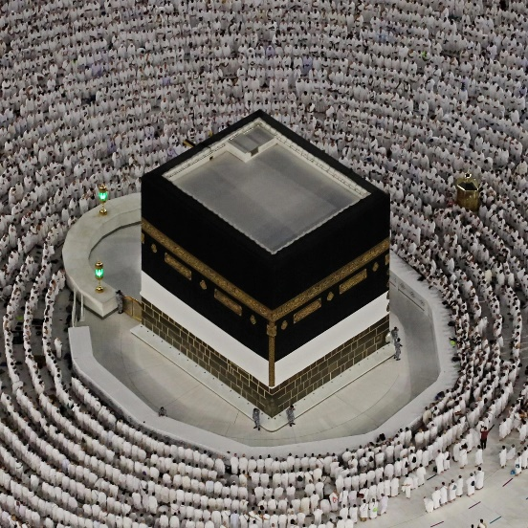
Jerusalem is a special place for different religions
Some Christians go on a pilgrimage to Lourdes, or Fatima in Portugal.
Muslims have to visit Mecca, once in their lifetime, as part of Hajj.

