Key Vocabulary
offspring | The young animal or plant that is produced by the reproduction of that species.
inheritance | This is when characteristics are passed on to offspring from their parents.
variations | The differences between individuals within a species.
characteristics | The distinguishing features or qualities that are specific to a species.
adaptation | An adaptation is a trait (or characteristic) changing to increase a living thing’s chances of surviving and reproducing.
habitat | Refers to a specific area or place in which particular animals and plants live.
environment | An environment contains many habitats and includes areas where there are both living and non-living things.
evolution | Adaptation over a very long period of time.
natural selection | The process where organisms that are better adapted to their environment tend to survive and produce more offspring.
fossil | The remains or imprint of a prehistoric plant or animal, embedded in rock and preserved.
adaptive traits | Genetic features that help a living thing to survive.
inherited traits | These are traits you get from your parents. Within a family, you will often see similar traits, e.g. curly hair.
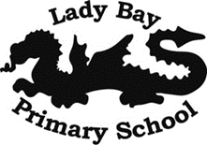
Year 6 Evolution and Inheritance
