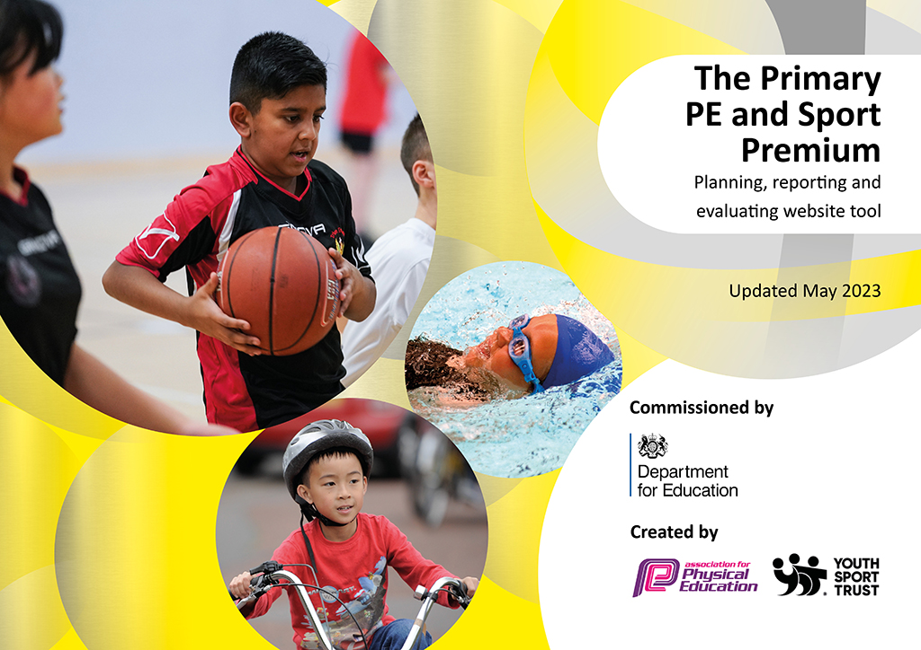
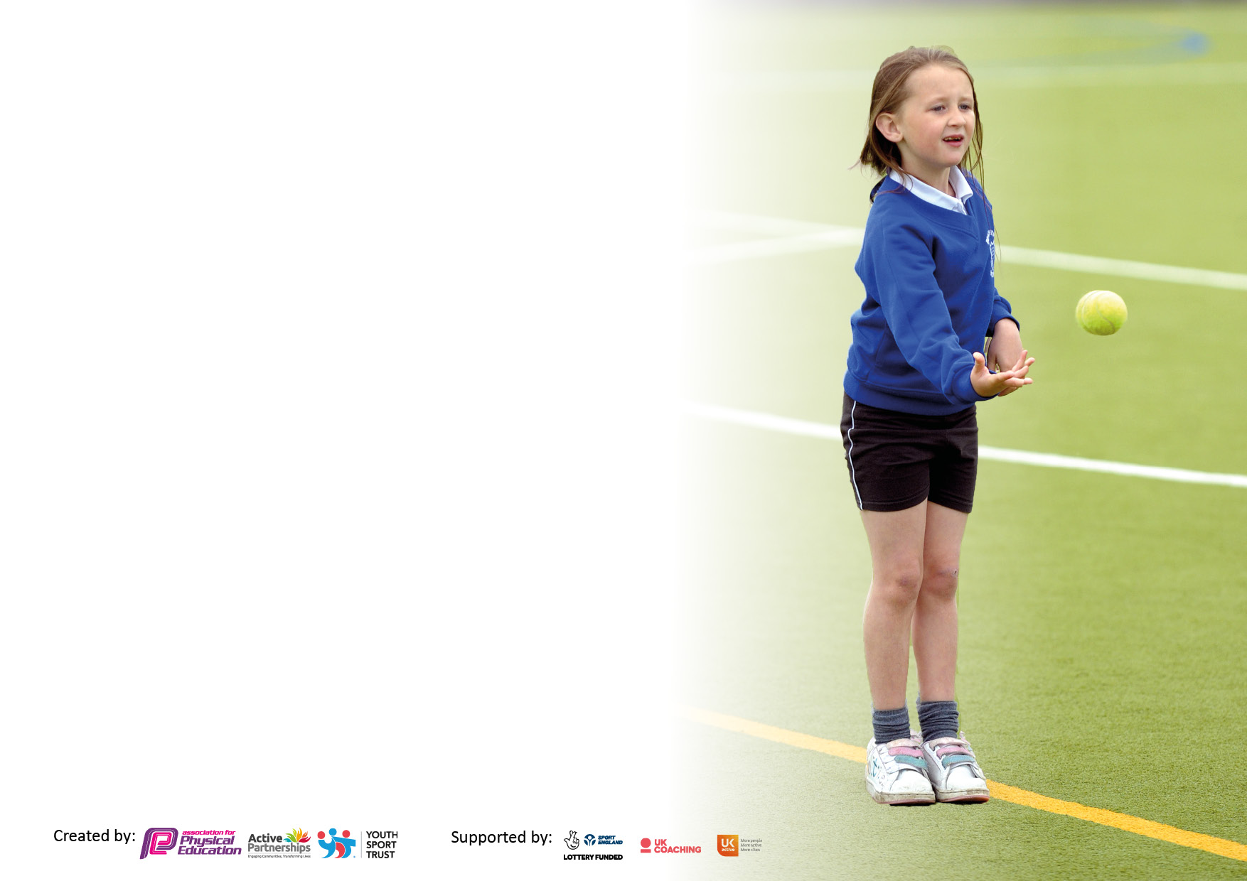

It is important that your grant is used effectively and based on school need. The Education Inspection Framework makes clear there will be a focus on ‘whether leaders and those responsible for governors all understand their respective roles and perform these in a way that enhances the effectiveness of the school’.

Under the Quality of Education Ofsted inspectors consider:
Intent - Curriculum design, coverage and appropriateness
Implementation - Curriculum delivery, Teaching (pedagogy) and Assessment
Impact - Attainment and progress

To assist schools with common transferable language this template has been developed to utilise the same three headings which should make your plans easily transferable between working documents.

Schools must use the funding to make additional and sustainable improvements to the quality of Physical Education, School Sport and Physical Activity (PESSPA) they offer. This means that you should use the Primary PE and sport premium to:

- Develop or add to the PESSPA activities that your school already offer
- Build capacity and capability within the school to ensure that improvements made now will benefit pupils joining the school in future years
- The Primary PE and sport premium should not be used to fund capital spend projects; the school’s budget should fund these.

Pleasevisitgov.ukfortherevisedDfEguidanceincludingthe5keyindicatorsacrosswhichschoolsshoulddemonstrate animprovement.Thisdocumentwillhelpyoutoreviewyourprovisionandtoreportyourspend.DfEencouragesschools to use this template as an effective way of meeting the reporting requirements of the Primary PE and Sport Premium.

We recommend you start by reflecting on the impact of current provision and reviewing the previous spend.

Schools are required to publish details of how they spend this funding, including any under-spend from 2021/2022, as well as on the impact it has on pupils’ PE and sport participation and attainment. All funding must be spent by 31st July 2023.

We recommend regularly updating the table and publishing it on your website throughout the year. This evidences your ongoing self-evaluation of how you are using the funding to secure maximum, sustainable impact. Final copy must be posted on your website by the end of the academic year and no later than the 31st July 2023. To see an example of how to complete the table please click HERE.

Details with regard to funding
Please complete the table below.

Total amount carried over from 2021/22 | £3430.32
Total amount allocated for 2021/22 | £19,549.00
How much (if any) do you intend to carry over from this total fund into 2022/23? | £0.00
Total amount allocated for 2022/23 | £19560.00
Total amount of funding for 2022/23. To be spent and reported on by 31st July 2023. | £19506.00
Swimming Data
Please report on your Swimming Data below.

Meeting national curriculum requirements for swimming and water safety.

N.B. Complete this section to your best ability. For example you might have practised safe self-rescue techniques on dry land which you can then transfer to the pool when school swimming restarts.
Due to exceptional circumstances priority should be given to ensuring that pupils can perform safe self rescue even if they do not fully meet the first two requirements of the NC programme of study
What percentage of your current Year 6 cohort swim competently, confidently and proficiently over a distance of at least 25 metres?  N.B. Even though your pupils may swim in another year please report on their attainment on leaving primary school at the end of the summer term 2022.  Please see note above | 91.4%
What percentage of your current Year 6 cohort use a range of strokes effectively [for example, front crawl, backstroke and breaststroke]?  Please see note above | 91.4%
What percentage of your current Year 6 cohort perform safe self-rescue in different water-based situations? | 91.4%
Schools can choose to use the Primary PE and sport premium to provide additional provision for swimming but this must be for activity over and above the national curriculum requirements. Have you used it in this way? | Yes £2793.00 (14.3%)

Action Plan and Budget Tracking
Capture your intended annual spend against the 5 key indicators. Clarify the success criteria and evidence of impact that you intend to measure to evaluate for pupils today and for the future.

Academic Year: 2022/23 | Total fund allocated: | Date Updated:
Key indicator 1: The engagement of all pupils in regular physical activity – Chief Medical Officers guidelines recommend that primary school pupils undertake at least 30 minutes of physical activity a day in school |  |  |  | Percentage of total allocation:
 |  |  |  | 8.9%
Intent | Implementation |  | Impact
Your school focus should be clear what you want the pupils to know and be able to do and about  what they need to learn and to  consolidate through practice: | Make sure your actions to achieve are linked to your intentions: | Funding allocated: | Evidence of impact: what do pupils now know and what can they now do? What has changed?: | Sustainability and suggested next steps:
To revisit daily physical activity (PA)  through active lessons and walking to school.  To make playtimes and lunchtimes more active  Phase groups to be given an amount to purchase new equipment to encourage more active play  To encourage active dance and movement at breaks using an outdoor speaker and itouch device  To upkeep/ repair/replace/store indoor/outdoor equipment for safe sustainable use | ‘Walk on Wednesdays’ initiative re- by the Eco team. The class with the highest number of children walking to school wins a prize.  New equipment ordered for rota to be introduced Sept 2023  Year group school council reps to find out what sort of play equipment their children would like to have that would encourage active play. Purchase as appropriate.  Dance leaders, set up the equipment at the start of lunchbreak and through demonstration and encouragement, get children moving to music  Be able to continue to utilise equipment for active play/ PE | /  £914.41  £305.00  £120.00  Subscription  £401.33 | % of children walking to school went up on Wednesdays, Children more alert for lessons and developing good active lifestyles.  Children are physically active for 30 minutes each day enhancing fitness and stimulating emotional wellbeing.  More children engaged in active lunchtimes.  Year groups use the ‘stage’ on a rota basis. Pupil voice shows this activity is popular  Children are able to continue to use equipment safely in an already restricted playing space. | Continue with this initiative for the forthcoming academic year, sharing data with children to further encourage walking to school.  SLT to devise a new lunchtime active play timetable/rota for September to further encourage all children to be active  Pupil voice at the end of the summer term to establish new ideas/initiatives for 2023/2024  Renew subscription for Spotify
Key indicator 2: The profile of PESSPA being raised across the school as a tool for whole school improvement |  |  |  | Percentage of total allocation:
 |  |  |  | 7.4%
Intent | Implementation |  | Impact
Your school focus should be clear what you want the pupils to know and be able to do and about  what they need to learn and to  consolidate through practice: | Make sure your actions to achieve are linked to your intentions: | Funding allocated: | Evidence of impact: what do pupils now know and what can they now do? What has changed?: | Sustainability and suggested next steps:
To buy into the Rushcliffe Schools Sport Partnership to keep abreast of new developments, implement the School Games agenda and promote inter school festivals and competitions. | Attend organised Partnership meetings at the beginning of each term to discuss how the School Games is evolving and the impact of this on school sport. Share information and updates with colleagues | £1455.00 | Discussion and clarification on latest developments, new initiatives and dates to plan for forthcoming festivals/events.  Updated on how the School Games is evolving - inclusivity and targeted groups with some competitive events  Introduce pupils to new sports such as Scatterball and Kingball | By involving different children participating in inter school events and festivals, more children will be encouraged to develop more active lifestyles and be enthusiastic to participate in future events.

Key indicator 3: Increased confidence, knowledge and skills of all staff in teaching PE and sport |  |  |  | Percentage of total allocation:
 |  |  |  | 25%
Intent | Implementation |  | Impact
Your school focus should be clear | Make sure your actions to | Funding | Evidence of impact: what do | Sustainability and suggested
what you want the pupils to know | achieve are linked to your | allocated: | pupils now know and what | next steps:
and be able to do and about | intentions: |  | can they now do? What has
what they need to learn and to |  |  | changed?:
consolidate through practice:
To continue to implement the GetSet scheme and deliver high quality PE lessons. CPD given by team teaching alongside First Grade sports coach one series of lessons from the Long term Plan  To upskill teachers in the teaching of tennis as they work alongside a qualified coach delivering a series of lessons to each class.  To offer a range of CPD courses/ training to meet the need of individuals: | Each member of staff to identify an area of their PE curriculum that they would like to develop and improve and then temporarily amend the LTP to enable this series of lessons to be delivered by the coach as individual CPD  All children to participate in Tennis lessons led by a qualified coach at Lady Bay Tennis club  PE Assessment JH (Jan)  Trent Bridge Cricket 23.3.23 JH  Golf training MK 19.4.23 | £3330.00  £700.00  £690.50  £115.00 membership | High quality lessons delivered. Pupil voice response indicates positive experiences had in PE lessons  All teachers shared their MTP with the tennis coach and the children subsequently experienced high quality tennis lessons with progressive knowledge/ skills within a professional club facility  Training allowed high quality afterschool clubs and enabled children to attend festivals events with the teachers involved  To keep abreast of new initiatives | To continue to offer this CPD to ensure a broad and balanced PE curriculum and high quality PE lessons are delivered by all.  To continue to develop links with this local facility and encourage more children to join a local sports club.
Key indicator 4: Broader experience of a range of sports and activities offered to all pupils |  |  |  | Percentage of total allocation:
 |  |  |  | 16.4%
Intent | Implementation |  | Impact
Your school focus should be clear | Make sure your actions to | Funding | Evidence of impact: what do | Sustainability and suggested
what you want the pupils to know | achieve are linked to your | allocated: | pupils now know and what | next steps:
and be able to do and about | intentions: |  | can they now do? What has
what they need to learn and to |  |  | changed?:
consolidate through practice:
To continue the provision of extra curricular sports/healthy living clubs (in line with the 2022/23School Games agenda)  To introduce the children to new sports and create positive, active experiences.  To continue to embed Drumba into the PE curriculum and as an after school club activity. | Staff to be offered an incentive to run a club for 6 hours (eg  6 x 60 mins/ 12 x 30 mins) for a targeted group of children – particularly encouraging the least active – to engage them in a new sport/activity and to promote physical activity (One day off in lieu - supply costs covered)  As part of Wellness Week,( all children from FS to Year 6) to participate in a Rebound Fit workshop and a Freestyle Football session  Drumba launch of how to get the most out of the equipment/license. Delivered CPD at staff meeting on September 23rd. | £780.00  Rebound Fit x2 day workshops £700.00  Freestyle football workshops £1135.00  £600.00 Renew ‘Go Virtual’ License | Clubs offered to all year groups and registers kept. Children have had experience of the following sports:  Year 3 Drumba club  Year 3 Drumba club  Year 1 /2 Drumba club  Year 6 Dodgeball club  Participation in both workshops was exceptionally high. Feedback from both staff and children for both activities was so positive that there has subsequently been requests for further opportunities to carry on with these two active sports.  3 x after school clubs have proved popular and 2 year groups have introduced Drumba into their PE curriculum | Use registers of attendance and  encourage these children to attend future clubs and encourage children not on the registers to attend a club next year.  Freestyle football masterclass after school clubs offered. 115 children expressed an interest  Drumba will continue to be taught/ developed as extra curricular activities/ class and group rewards/ if PE is cancelled due to poor weather etc

Key indicator 5: Increased participation in competitive sport |  |  |  | Percentage of total allocation:
 |  |  |  | 28%
Intent | Implementation |  | Impact
Your school focus should be clear | Make sure your actions to | Funding | Evidence of impact: what do | Sustainability and suggested
what you want the pupils to know | achieve are linked to your | allocated: | pupils now know and what | next steps:
and be able to do and about | intentions: |  | can they now do? What has
what they need to learn and to |  |  | changed?:
consolidate through practice:
To continue to develop and promote Intra and Inter school sport in line with the evolving School Games agenda | Staff to be offered an incentive in order to take children to off-site competitions and festivals out of school hours.  All children to participate in an Intra school Sports day | ½ a day off (supply costs covered)  £4438.00  £174.00 =  Transport costs  £801.00 = Hi Vis vests  £54.12 Sports day stickers | Enriched opportunities to get involved in extra curricular sport - both targeted children who do not usually participate and more able children to have opportunity to compete  Competitions and festivals undertaken:  Tag rugby, Girls football, Boys football, Mixed football, Cross Country, Sportshall Athletics, Physical Literacy, Boccia, Multi Skills. Dodgeball, Netball, Rounders, Cricket.  Positive participation and enthusiasm and general feedback very positive from pupils/ families/ people in the community | To build on from all of the opportunities offered this year and target more/ different children to take part in an event in the next academic year.  Continue to encourage different staff members to take up the incentive and offer more opportunities  Future sports days to be held in a similar way – inclusive yet competitive

Signed off by
Head Teacher: | Steve Border
Date: | 13.7.23
Subject Leader: | Lynn Davie
Date: | 13.7.23
Governor: | Alison Thomas
Date:

