

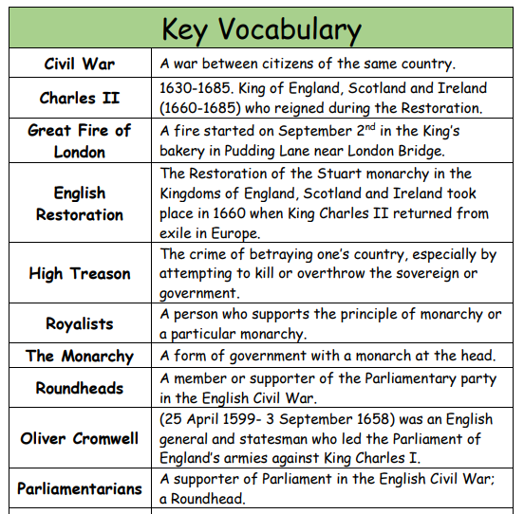
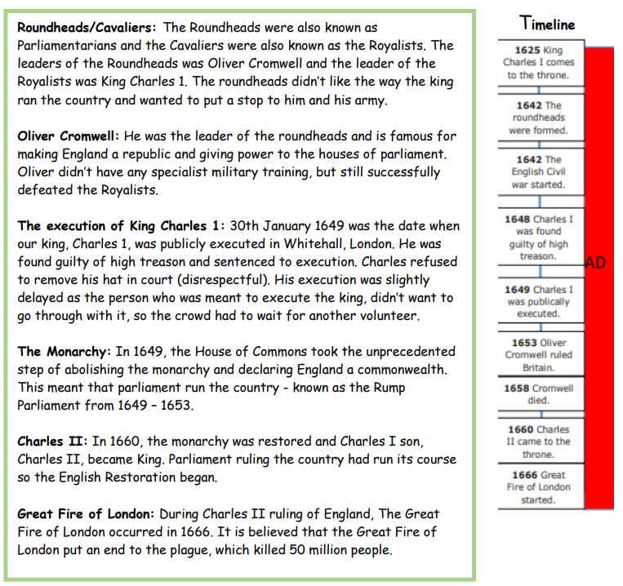
Sticky Knowledge
• To know what the definition of Civil War is.
• To know the dates of the period of English Civil Wars from start to finish.
• To name two key figures in the English Civil War.
• To name the two sides that were represented in the English Civil War.
• To identify the three main causes of the English Civil War.
• To identify two key events after The Restoration.

