Art Policy
Lady Bay Primary School

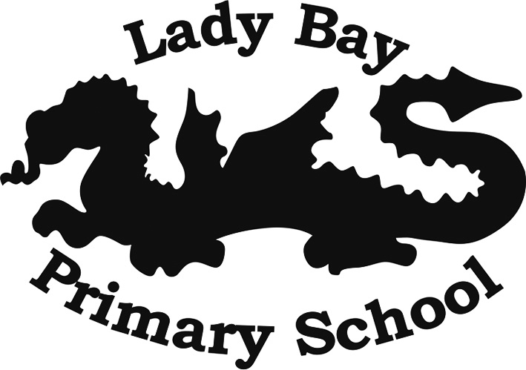

Reviewed by: Caroline Quigg

Approved by: Steve Border

Contents
- The ‘Lady Bay Way’ in Art and Design
- Statement of intent
- Teaching
- Assessment and reporting
- Roles and responsibilities
- Health and safety
- Legal Frameworks
- Monitoring and review of this policy

The ‘Lady Bay way’ in Art and Design
Art at Lady Bay aims to engage, inspire and challenge pupils and to equip them with the knowledge and skills to experiment, invent and create their own works of art, craft and design so that they leave Lady Bay with an enjoyment for the subject. To achieve this, we follow a series of stages;
Planning
Each year group is taught three art topics from the National Curriculum Art and Design Programme of study during the year. Teachers use the Lady Bay Progression in Art to ensure that specific art knowledge and skills are taught progressively by age. Medium Term Planning and Knowledge Organisers outline the skills and knowledge to be taught and what skills and knowledge should be retained by all children.

Teaching
In art lessons, the knowledge and skills are taught through the Rosenshine principles. Each lesson begins with a ‘big question’ and new knowledge or skills are presented in small steps. Naturally, the prior skills/knowledge that have been taught are revisited.

Assessment
The assessing of knowledge and skills is on-going in a lesson through the revisiting of questioning. At the end of a piece of work, teachers highlight the ‘big question’ either orange (did not meet the objective), green (met the objective) or blue (exceeded the objective) to aid overall assessment. Teachers make a final assessment judgement and record this on Sonar.
Floor books help to provide an ongoing record of work and assessment in EYFS for each child against the early learning goals.

Intent
At Lady Bay, we believe Art and Design helps our children not only develop their artistic skills and knowledge but also have the opportunity to express themselves and their individuality in a visual form. It is a subject which everyone can access, regardless of their English and Maths skills. Art stimulates creativity and promotes imagination. Because the results of an art lesson are so visual, tangible and immediate, it gives children the opportunity to gain great satisfaction from their creations, learn how to appraise their own work and see immediate results when they make changes. Art provides children access to cultural richness and diversity, finding out more about the world around them now and in the past, which helped shape what our culture is today. It is fundamental for our children to be engaged, inspired and challenged, and to acquire the ability to make informed critical responses to their own work and that of others.
- We aim to present, scaffold and teach skills and knowledge in inclusive, inspiring and relevant ways.
- Produce creative work, exploring their ideas and recording their experiences.
- Develop core skills in drawing and painting whilst also experiencing sculpture, collage, and printing techniques.
- Evaluate and reflect their own artwork.
- Opportunities to learn about great artists and understand the historical and cultural development of their art forms.
Implementation
Art and design is taught over three half terms, focusing on knowledge and skills stated in the National Curriculum. Teachers use a variety of teaching and learning styles in art lessons that are matched to the activity and ability of pupils. The main aim of these lessons is to develop pupils’ knowledge, skills and understanding using the progression of skills ladder to support their learning. The progression of skills document ensures the curriculum is covered and the skills/knowledge taught is progressing and deepening the children’s knowledge across the year groups.
We aim to ensure that all pupils:
- To have rigorous thorough exploration of artists, ideas and skills. Artists from different eras of studies throughout school to give our children a balanced knowledge and understanding of art concepts.
- An understanding of an artist’s purpose and how they use the formal elements of art to communicate their ideas to the viewer.
- Throughout the year, artwork is celebrated using displays both in classrooms and in shared areas giving our children a sense of pride in their achievements.
- Individual sketchbooks are used for research, practising skills, final pieces of art and reflections. They show each child’s art journey throughout school.

EYFS
In foundation stage, art skills are introduced through the specific area of Expressive Art and Design. Children are encouraged to explore colour mixing, use lines to enclose a space, and then begin to use these shapes to represent objects. This learning is delivered through adult led carpet, group sessions and also during continuous provision, where children develop their own art skills. Adults make notes of children’s comments and take pictures of their work they produce to evidence their skills and knowledge progression to ensure they are meeting the Early Learning Goal. Floor books help to provide an ongoing assessment and evidence base for all the children.

Key Stage 1
In key stage 1, children are taught to use a range of materials creatively and to design and make products. Children also use drawing, painting and sculpture to develop and share their ideas, experiences and imagination. They develop a wide range of art and design techniques in using colour, pattern, texture, line, shape, form and space. Children learn about the work of a range of artists, craft makers and designers, describing the differences and similarities between different practices and disciplines, and making links to their own work.

Key Stage 2
In key stage 2 children are taught to develop their techniques, including their control and their use of materials, with creativity, experimentation and an increasing awareness of different kinds of art, craft and design. Children improve their mastery of art and design techniques, including drawing, painting and sculpture with a range of materials [for example, pencil, charcoal, paint, clay]. Children also learn about great artists, architects and designers in history.
Assessment
Assessment of art in EYFS, KS1 and KS2 will be based on teachers’ judgments. Progress is measured against the Lady Bay Progression in Art and the National Curriculum. Assessment will be undertaken in various forms, including the following:
- Pupil Voice
- Highlighting of the big questions at the end of each lesson/topic (assessment sheet to be stuck in at the beginning of each new topic)
- Drawing skills sheet (Y1-6 to do this at the beginning of each new academic year)
- Pupils’ self- evaluation of their work
- Knowledge of tools, materials and equipment
Non- negotiables:
- Short date on each piece of work
- Big question assessment sheet to be stuck in the sketchbooks at the beginning of each topic
- No learning objectives on work
- Each year group to do the same drawing sheet at the beginning of the year (assessment/progress purpose)
Roles and Responsibilities
As a teaching staff, there is a collective responsibility to ensure the art curriculum is implemented effectively through well planned schemes of work, ensuring the progression of skills across school and assessing effectively. Additional responsibilities fall in the following areas:

The Art Lead is responsible for:

- Developing, resourcing and reviewing the school’s Art Policy.
- Monitoring planning and teaching.
- Liaising with colleagues, including the SENCO, to differentiate teaching programmes in accordance with the needs of individual pupils.
- Working with other staff to teach the subject content.
- Organisation of the Lady Bay Arts Trail with the community.
- Keeping staff informed of visits and courses.
- Facilitating the assessment of children’s work.
- Keeping up-to-date with current affairs and best practice regarding art.
- Providing guidance, including INSET training to art staff, as part of their ongoing professional development.
- Celebrating and promoting the art curriculum and the work of pupils’ throughout the school.
- Create an annual action plan which supports the development of the subject.

The Governors are responsible for:
- Approving and monitoring the content of this policy.
- Liaising with the Headteacher with regards to pupil progress and attainment.
- Liaising with the Curriculum Leader (Deputy Headteacher) who assists the school with the creation and implementation of the curriculum.
- Ensuring the curriculum is inclusive and accessible to all.

Health and Safety
Pupils will be taught to use materials, tools and equipment safely in line with the school Health and Safety Policy. The use of tools and equipment will be closely supervised by teachers and sharp tools introduced appropriately.
Equal Opportunities
We are an inclusive school that ensures all pupils are provided with equal learning opportunities, regardless of their characteristics or backgrounds. Teachers will adapt how they deliver the art and design curriculum based on the needs of pupils. In order to ensure pupils with SEND achieve to the best of their ability, teachers will adapt targets and the delivery of the curriculum for these pupils. The school aims to maximise the use and benefits of art and design as one of many resources to enable all pupils to achieve their full potential.
There are nine protected characteristics outlined within the Equality Act 2010, these are:

• Age
• Disability
• Gender reassignment
• Marriage and civil partnership
• Pregnancy and maternity
• Race
• Religion or belief
• Sex
• Sexual orientation
The school does not tolerate any form of bullying or discrimination against people with one or more of these characteristics.
The school’s curriculum will celebrate diversity and the SLT has a responsibility to ensure that the curriculum does not discriminate against any of the above characteristics.
The school will have due regard for the Equal Opportunities Policy at all times when planning and implementing the curriculum.

Monitoring and review of this policy
This policy is reviewed annually by the Art Leader, Head teacher and the Governors. Any changes made to this policy will be communicated to all members of staff and relevant stakeholders. This policy will be communicated to parents and other stakeholders via the school website.

